MOVEMENT DURING LAW ENFORCEMENT
LETHAL FORCE ENCOUNTERS

Phillip Groff
Vigr Training LLC.

Table of Contents Page(s)
Definitions 2 - 3
Section 1 – Introduction & Legacy Training Approach 4
Section 2 – Legacy Training Approach 5 - 7
Section 3 – Lethal Force Event Data 8 - 12
Section 4 – Primary Movement Analysis 13 - 26
Section 5 – Secondary Movement Analysis 26 - 27
Section 6 – Recommendations for Training Practices 28 - 30
Section 7 – Conclusion 31
Section 7 – Video Links 31 - 45
Definitions

Lethal Force Encounter (LFE) - An event in which the responding officer fires their weapon. Can also be an event in which the officer is confronted by a threat capable of inflicting immediate death or serious bodily injury and the officer does not fire their weapon.

Non-Movement (NM) - A Non-Movement LFE is where an officer fires their weapon from a stationary position. Included in NM events are instances when an officer is not stepping, walking, running or otherwise engaged in continuous motion while addressing the threat. NM does include flinching, ducking, leaning or other movements that do not constitute any other movement type.

Turning Movement (TM) - Turning movements include all turns, pivots, and changes in directional orientation when that is the only movement present. TM would otherwise be listed as a NM if not for the redirection of the hips. If the officers move outside of the space they occupy at the time of the movement, that would be listed as one of the other types of movement.

Short Movement - Short movement is when an officer moves within the time space that is required to present and fire the weapon. The movement can be in any direction but must generally terminate once the weapon is ready to be fired. Short Movement is broken into two categories within this study; Short Movement from Ready (SMR) and Short Movement from Holster (SMH)

Long Movement (LM) - Long movement is any distance covered that is in excess of the time it takes to present the weapon. Long movement is further broken into two categories: Move Then Shoot (MTS) and Shooting on the Move (SOTM).

Move Then Shoot (MTS) - During a MTS movement the officer moves but has stopped or is in the act of stopping movement at the time they fire. Firing shots while entering a stationary position but still in motion are also considered MTS.

Shooting on the Move (SOTM) - Shooting on the Move is when an officer discharges their weapon while in constant motion.

Protective Movement (PM) - Protective movement is when the officer employs any of the other types of movement but does not return fire or attempt to use force during that movement.

Primary Movement Type (PMT) - The primary movement type refers to the type of Officer movement at the moment of the initiation of the Lethal Force Event. Officer movement types are not considered prior to the LFE and any changes in the type of movement would be considered Secondary Movement Type.

Secondary Movement Type (SMT) - Secondary Movement Type are recorded when an officer uses more than one of the Movements (NM, TM, SMR, SMH, MTS, SOTM, PM). Not all events include a SMT. Movements after the cessation of the LFE are not recorded similarly to how moves prior to the LFE are not recorded.

Non-Projectile Weapon - Any object, weapon, tool or vehicle not capable of firing a projectile at lethal velocities. Examples include edged weapons, blunt force weapons, and vehicles. This category does NOT include projectile weapons other than firearms such as bows, crossbows, slingshots, and ballistic knives.

SECTION 1 – INRODUCTION

Modern Law Enforcement training methodologies have placed an increasing emphasis on movement principles, concepts, and drills. This renewed focus over the past several decades has become disconnected from the realities of an actual lethal force encounter. Instead, it focuses on outdated, unrealistic, legacy training that does not reflect behaviorally compliant methodologies. The goal of this paper is to study the movement principles of Officers during lethal force encounters, identify current deficiencies in training, and determine the best practices to enhance Officer’s performance.

This study will explore the data and trends observed in 700 Law Enforcement Lethal Force Encounters. To be considered in the study the incidents had to include officers using deadly force or under direct, immediate threat of deadly force. Additionally, all incidents were recorded at the time of the LFE and the officers’ movements had to be visible. Most of the incidents within this study are from the past five years and have been recorded on body worn cameras. There are cases included in the study shown from in-car cameras, surveillance cameras, ariel cameras, and other recording devices. Only incidents in which the officer’s movements can be clearly determined are included.

All cases recorded involve Law Enforcement Officers. There is no civilian only incidents within this study. Over 90% of the incidents recorded are from Patrol, the remaining incidents include SWAT, Investigators, Plain Clothes/UC and Off-Duty. No Military/Combat examples are included within the paper as I wanted to keep the scope of the study isolated to Law Enforcement.

SECTION 2 – LEGACY TRAINING APPROACH

Training for movement within the context of human conflict is as old as combat itself. Throughout recorded history and in all Martial Sciences, movement is understood to be a key component of preparing for interpersonal violence. Within the last several decades Law Enforcement training has continued this tradition of attempting to prepare officers for conflicts that are mobile. Specifically related to Police Firearms Training emphasis has been placed on preparing officers for movement during a gunfight. It is within this area we seek to address the current common practices and identify any behavioral disconnections.

There is little consistency in the manner in which individual agencies address the topic of movement within their firearms training. Even rarer, are departments that identify movement types based on common behavior patterns and structure a training program around them. Like with all topics, there is a generally acknowledged deficiency in both initial and sustainment firearms training across the nation. Officers, depending on State requirements and individual agency TTPs may conduct live-fire training one time per year or as often as monthly. Most officers across the country fall much closer to the lower end of that scale. It is very rare to find agencies that train more than 2-4 times per year. Training is infrequent and mostly geared towards conducting state mandated qualifications.

Training specific to movement is often introduced at the Academy level of instruction and then included periodically throughout an officer’s career. It is also common for officers to conduct several types of movement within a qualification process without further discussion or understanding of how that movement may occur in an actual encounter.

The most common training trends related to movement are pivots (Turning Movements), stepping draws, and shooting on the move. Many instructors place a signifigant emphasis on the concepts of shooting on the move when discussing movement in an LFE. There are common clichés related to movement and I have observed countless instructors advise their officers that movement in a fight is a 100% guarantee. This continued focus on shooting and moving simultaneously has also caused many variations of training methodology specific to SOTM. They include concepts such as; moving only as fast as you can accurately shoot, moving at a situationally realistic pace, alternate walking methods (Groucho, combat glide, ,etc.), limitations of movement patterns (no crossing feet), crossing feet is OK, never move backwards, fight forward into the know, and on and on. The only consistency within many of these legacy SOTM training approaches is that they are isolated to performance in a low stress range environment with little consideration to human behavior factors within a real encounter. Over decades these training practices have become entrenched into TTPs of agencies regardless of whether they had any real training value. The result of this ongoing conditioning is that officers receive little focused movement training and the training they do receive does not accurately reflect the manner in which they are likely to perform in an encounter.

Within the past ten years, particularly the last 5, Law Enforcement has seen a signifigant increase in the number of incidents that are visually captured in one form or another. The use of in-car camera systems is certainly not new and for decades these were the primary source for video analytics. One of the primary draw backs of the in-car system is the limitations to capture action outside of a very narrow window directly in front of the Officer’s cruiser. Over the past 5 years, the use of body worn cameras have greatly increased the number of reviewable incidents and expanded the types of calls they captured exponentially. In addition to the cameras used by law enforcement the increase in proliferation, quality of cell phone camera technology, and home surveillance systems has led to a high number of LEO lethal force encounters being captured digitally.

As we seek to understand the information this additional data provides, we must acknowledge some of the limitations in legacy systems to avoid repeating those failures. Before cameras rose to the current level of use, eyewitness accounts and forensic re-creation of OIS events were the most common investigative tools. Trainers and administrators in forward thinking agencies often used this data to identify trends and adjust training methods to address those trends. Analysis of movements by the officers, suspects, and other participants was not uncommon. In many cases this focused on the overall positioning and general timing. The specific facts and seemingly inconsequential details of how officers moved were often exceedingly difficult to relate accurately. In addition, absent footage from an event it was often an officer’s individual recollection of their movements, timing and actions. Involved LEOs are at equal risk to the general population of having memory, timing, and sequencing distortions as they relate details of an event. In many OIS investigations the idea of analyzing specific movement patterns and types were not present. When movement details were discussed in the investigation or a training focused debrief after the fact, it was common for officers to validate the training they had received. Again, absent the use of video, these small details were not questioned and rarely had signifigant effect on a criminal investigation or internal review. This increase in review, investigations, and accountability since the mid-1980’s gave rise to the enhanced emphasis on Shooting on the Move. Officers reported moving and shooting, without additional detailed analysis of the timing. Trainers began to run with concepts of SOTM as the most important skill set for an LFE. As you will see later in this report, SOTM incidents only account for 10% of all fights. Fast forward to the last 5 years and we are now operating in a time where the smallest of detail can be reviewed and analyzed. As we look at incidents and the performance factors at play, this study will outline and highlight some of the key findings to focus training.

The final legacy training concept that bears mentioning is that of required repetition to produce subconscious competence or “muscle memory.” Most of, thankfully not all, current training methodology within the Law Enforcement community are predicated on the concept that peak performance can be achieved through repetition. This idea alone is absurd as we have previously mentioned the generally accepted understanding that LE training time is at best, insufficient, and at worst non-existent. The idea that any officers are receiving sufficient training repetitions in any skill to build an automated reaction capable of overriding core survival responses is not valid. As it relates to firearms training and movement specifically, we see this applied in the notion that one’s movement can be dictated by how one practices and not the environment or stimulus. There is little attention paid to the concept of human behaviors given a variety of stimulus. The common current training mindset is one that performance in a skill can be achieved through repetition no matter the stimulus. This reliance on continuing within this flawed model helps to widen the gap between how we train and the actions we see performed in real events. The previously stated example of some trainers warning officers to “never back up,” is one perfect example. As mentioned, SOTM was the primary movement type in 10% of cases. Within those SOTM, the majority of those cases (61%), officers were moving in the rearward plane of motion. This movement was almost universally an attempt by the officer to create distance from themselves and the threat. Current legacy systems that eliminate rearward movement in training are poorly preparing their officers for the real range of motion within an encounter. Even if officers were given sufficient training time and repetition it would be impossible to deprogram a hardwired survival instinct. Gaining distance from a threat is a common universal behavioral pattern and one that cannot be “trained out.” This continued reliance on the concept of muscle memory must be addressed and replaced with a behaviorally compliant model.

SECTION 3 – LETHAL FORCE EVENT DATA

1. INCIDENT TYPE

The purpose of this study is to examine the physical movements officers make during a lethal force encounter. Within this context it can be helpful to understand the basic types of calls officers were engaged in at the time the LFE occurred. During video review the types of LFE were categorized into 16 different call types. These categories were kept general and designed to reflect the most accurate type of encounter at the time of the LFE as opposed to whatever the initial call type when dispatched to officers. In many incidents studied, the initial dispatched call type is not known but based on the actions of suspects and officer, a general call type can be established.

As an example, an officer(s) may be dispatched to a noise complaint call with no additional information or details. Upon arriving at the scene, the officer is confronted with a subject holding a knife. The subject approaches the officer and refuses all commands to drop the knife. In the context of this study, that call type would be listed as a “Weapons” event.

The classifications for this text do not follow other the criteria or definitions of other studies. This accounts for differing numbers in statistics between this work and other readily available data on Law Enforcement call types from DOJ studies, LEOKA, etc. The goal is to capture the incident type at the moment of the lethal force event.

A total of 700 Law Enforcement Lethal Force Encounters were used in the initial data set.

CALL TYPE BREAKDOWN
Weapons 186
Arrest Control 79
High Risk Vehicle Stop 66
Foot Pursuit 60
Vehicle Pursuit 54
Traffic Stops 48
Perimeter Operations 44
Building Search 30
Ambush 29
Disturbance 21
Domestic 20
Active Shooter 18
Warrant Service 18
Robbery 17
Open Air Search 8
Burglary 1

The most prevalent call type observed was Weapons at 27% of studied cases. This category broadly covers all incidents in which a suspect was armed, or believed to be armed, with a deadly weapon. The weapons included firearms, edged weapons, blunt force weapons, facsimile weapons, and improvised weapons. The officer was aware of the presence or potential presence of the weapon prior to the suspect using said weapon. Cases where suspects attacked officers before the confirmed presence of a weapon were listed as Ambush.

The second most common incident type studied is Arrest and Control at 11%. Arrest and Control were categorized when officer(s) were in a hands-on, physical attempt of an arrest.
Foot pursuits made up 9% of cases. Foot Pursuits can be closely tied to Arrest and Control as they are an attempt by the officer to control the movements of a suspect, bring them under physical control, and stop the efforts to escape. Foot pursuits are unique to all other incident types in that the officers are always in a state of movement prior to the lethal force event. We will explore further the impact this has on the movement patterns during a LFE compared to all the other incident types in which the offier may have been stationary prior to the encounter.

High Risk Vehicle Stops (9%), Vehicle Pursuits (8%) and Traffic Stops (7%) are all related call types. Incidents in this study were classified as Vehicle Pursuits if the LFE occurred during the moving pursuit or immediately following the cessation of movement of the vehicle. In events listed as vehicle pursuits a formal or hasty HRVS had not yet been established at the time the LFE began. In incidents listed as HRVS, attempts to gain compliance of the subjects through verbal commands had been established and a variety of techniques employed up to the point of arrest/control are attempted. Vehicle stops listed in this paper are incidents in which the LFE developed rapidly from what was believed to be a routine traffic stop.

These top six categories account for 71% of all recorded incidents. The remaining call types represent 6% or less per type. The data within this study does differ from other sources as the call categories and criteria are modified to focus on the moment of the LFE. Contrast this with sources such as the Law Enforcement Officers Killed or Injured Data (LEOKA). Within line of duty deaths in LEOKA we see different criteria and varying percentages. The top category within this report, Weapons, is covered under a wide number of call types listed in LEOKA. A direct one-to-one comparison would be nearly impossible given the information available. The remaining categories in the top six of this report are more clearly defined in LEOKA and a closer comparison can be achieved:

CALL TYPE MOVEMENT STUDY LEOKA (2015-2019)
Arrest Control 11% 5%
HRVS 9% .004%
Foot Pursuit 9% 6%
Vehicle Pursuit 8% 3%
Traffic Stop 7% 6%

2. OFFICER’S WEAPON TYPE

3. OFFICER’S WEAPON STATUS

Within this data point, the status of an officer’s weapon was recorded at the initiation of the Lethal Force Event. Determining whether an officer was holstered, at the ready, or aimed in on a threat will help us determine later if this has any correlation to primary movement types. Additionally this information can be utilized to determine best practices in training. Currently the overwhelming majority of Law Enforcement firearms training is conducted from the holster. This legacy training methodology is in contrast to the realities that only 20% of observed incidents started with officers having a holstered weapon.

Officers at the ready position accounted for the majority of all LFE observed. This statistic includes all types of ready positions including; low ready, high ready, safety circle, SUL, high index, carries and other unconventional positions. To be classified as a ready position, the officer has to make a detectable movement to get their sights on target and fire a shot. From the aimed position the officer makes no signifigant movement prior to being able to fire a shot. The holstered position means that the officer was carrying the handgun secured in the holster until which time the LFE begins and the officer immediately fires rounds. This would be the most common manner in which firearms training occurs. Officers are given a stimulus and immediately draw and fire their weapon as quickly and efficiently as possible from the holster.

This information clearly shows that the ability to draw efficiently and make a hit on a threat is an important skill but one that should be trained within realistic data driven percentages to other presentation skills.

3. LFE INITIATOR

This data point seeks to track whether the officer or suspect fires the first shot. This category is strictly limited to the first shots fired and does not consider other threatening actions that may justify deadly force. In instances where the offender is unarmed or armed with a Non-Projectile Weapon, the officer is always listed as having fired first.

SECTION 4 – PRIMARY MOVEMENT ANALYSIS

The idea of examining the movements Police Officer’s make during a Lethal Force Encounter is the driving force behind this entire study. This section will look at the ways in which officers move at the exact moment an LFE begins. In subsequent sections we will explore secondary movements, or examples when officers use multiple types of movement in a single encounter.

I have chosen seven primary movement types for the purposes of this study. Each type is detailed in the definitions section. The seven movement types are:

1. No Movement
2. Turning Movement
3. Short Movement from Ready/Aimed
4. Short Movement from the Holster
5. Move Then Shoot
6. Shooting on the Move
7. Protective Movement

Within each of the movement types, several factors and specifics will be explored. The direction of movement will be cataloged to examine whether trends emerge regarding directionality based on the movement type. Additionally, it will be examined whether or not secondary movement patterns were seen after the initial movement pattern. Finally, several links will be provided within this text for each of the movement patterns that best represent that movement type. All video links are included in the references section.

OVERALL MOVEMENT BREAKDOWN

OVERALL OBSERVATIONS - The most profound observation when looking at the overall distribution of movement within a LFE is the lack thereof. No Movement accounted for 382 of the 700 studied events, nearly 55%. Movement at the instant of an LFE is what is being covered within this statistic. Officers typically move before or after the LFE and these movements are not included in these statistics. It is my suspicion that this movement, disassociated with the LFE is what causes many officers to believe that movement during the fight is universal. One of the biggest factors that drove these stationary firing numbers involved officers that took a tactically advantageous position prior to the initiation of the LFE. These Officers were far more likely to fire in stationary positions than those that took less prepared positions. It also bears noting that the 3 most common movement training topics (turning, short movement from the holster and shooting on the move) only account for 15% of all encounters.

1. NO MOVEMENT

Overview
Officers fired from a stationary or nearly stationary position in 382 incidents observed. No movement does however include officers that flinched, crouched, leaned, but did not otherwise take a step or change their position while firing. The call types in which No Movement was observed mirrored the percentages in the top three call types: Weapons, Arrest Control, and HRVS. The next two most common call types were foot pursuits and vehicle pursuits. When examining the No Movement pattern in officers those two call types are replaced with Perimeter and Traffic Stops in the top 5. This is in keeping with the earlier observations about officers taking a tactical position early and not needing to move once the LFE began.

When reviewing example videos, remember that No Movement includes anything that would not be classified as other movement types. It does not mean completely motionless or frozen at the time of the LFE, simply that any leans, momentum, or crouches were not enough to be included within the short movement classification.

Directionality
With no movement there is no directionality present.

Example Links:

https://www.youtube.com/watch?v=Ncg1g5KdAV0

https://www.youtube.com/watch?v=K7ZbPA8cG2Y

https://www.youtube.com/watch?v=ynWBfhzMEV4

https://www.youtube.com/watch?v=Dg34VnNXR-k

https://www.youtube.com/watch?v=-zo7mfZYmbM
2. TURNING MOVEMENT

Overview
Turning movements account for a statistically insignificant number of incidents. The criteria to be considered a turning movement was when the officer only turned their body without any additional stepping or movement. Of 700 incidents, 318 of which included movement, only three events included what could be considered a pure turning movement. This represents less than 1% of all types of movements.

Even though turning movements make up a minute fraction, the act of reorienting the hips is often a part of many of many other observed movement patterns. In a later section, I will make recommendations for the implementation of turning movements as they relate to other patterns of movement within the overall training scheme.

Directionality
With so few instances, there is no statistical trending related to turning movement directionality. Through the three incidents observed and in all other movement types, directionality of the hips (turning) is related to 2 distinct factors; threat orientation or direction of movement. Officers turned their hips to face their threat or they turned to face the direction they were looking to travel. In all three incidents of this study the officers turned towards the threat or tracked a moving threat by utilizing a turning movement.

Example Links:

https://www.youtube.com/watch?app=desktop&v=GCZH8Bv-8BA

https://www.youtube.com/watch?v=RhbTLlM2TdU&list=PLW5iqZEagvjMvmXRnBaYqozLYwmzUO2B9&index=46

https://www.youtube.com/watch?app=desktop&v=ZN3JjkItnlo

3. SHORT MOVEMENT FROM READY/AIMED

Overview
Short Movement from Ready (SMR) is the second most common movement pattern observed, accounting for 85 of the 700 events recorded or 12%. When movement was used, SMR was seen in 27% of movement-based incidents (85/318). There was very little difference in the movement, timing and directionality between ready and aimed within this category. In training, reaction and hit times can easily be measured and evaluated. The time an officer can make a hit from either aimed or ready can be accurately measured. When target identification and judgement are not present, officers are statistically faster the closer they are to the final firing position. This makes complete sense within the concepts of efficiency as the officer has less physical movement to complete the firing event. During live events in which judgement and justification factors are fully present, there was no noticeable time difference between aimed and ready. Officers that were already aimed in on the threat did tend to move shorter distances prior to firing than the officers who are at the ready before firing.

Directionality

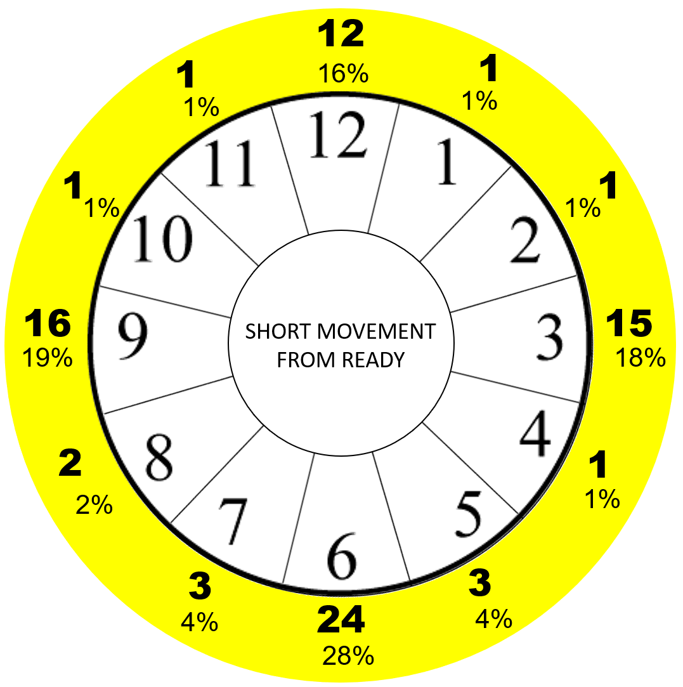

Movement in the rearward plane of motion was the most prominent direction, making up nearly 40% of all movements. Backing directly away from a threat account for 24% of SMR movements making the 6 o’clock direction the most used. Movements made in the four primary compass directions (12, 3, 6, 9) made up 70%.

The findings of rearward movement are in alignment with sympathetic nervous system responses to danger. Within the context of “fight or flight” responses, flight indicates a general movement away from the danger. We see this reflected in the movements listed above where an officer reacts to a threat by moving away. Movements in a lateral direction were generally observed when an officer was moving to gain an angle to deal with the suspect or clear an obstruction the officer was using as cover or concealment. Movements in the forward plane were most observed in instances where officers were not under direct immediate threat.

The distance of movement in most cases was less than six feet and was often a single step. Regardless of the distance, officers appeared to fire their weapons as soon as they believed to be on target. This accounts for shots being fired in either a state of motion or nearly stationary. When the shots were fired while still moving, the officers stop the continuous movement even while continuing to fire. In instances where movement and delivery of force remain constant, that would be considered shooting on the move and will be covered in subsequent sections.

Example Links:

https://www.youtube.com/watch?app=desktop&v=ygbOLb0O7Pw&bpctr=1611952245
Short Movement from ready to the rear.

https://www.youtube.com/watch?app=desktop&v=XMI1YVGGr7g
Short Movement from ready to the rear.

https://www.youtube.com/watch?app=desktop&v=l_dE_aMiD6E
Short Movement from ready

https://www.youtube.com/watch?app=desktop&v=lXTZZ3ZCzTc
Short Movement from aimed to the right.

https://www.youtube.com/watch?app=desktop&v=yHK41COLq6Y
Short Movement from ready to the left.

4. SHORT MOVEMENT FROM THE HOLSTER

Overview
Short Movement from the Holster (SMH) accounts for 5% of all incidents and 11% of all movement events within 35 observed instances. In total officers were holstered 140 of the 700 incidents reviewed. In the remaining events where officers were holstered at the time of the initiation of the LFE, officers took the following movement actions:

- 37 No Movement
- 10 SMR (weapon was drawn but not immediately used)
- 26 Move then Shoot
- 11 Shooting on the Move
- 21 Protective Movement

Present in this category are the examples of officers that observed the LFE, drew their handguns and immediately fired. Some of the common movement patterns observed were exiting the patrol car while simultaneously drawing their firearm. This type of movement is routinely included in firearms training through the use of stepping draw drills. Some agencies have gone as far as to mandate a step to a prescribed direction during every single draw during training.

Directionality

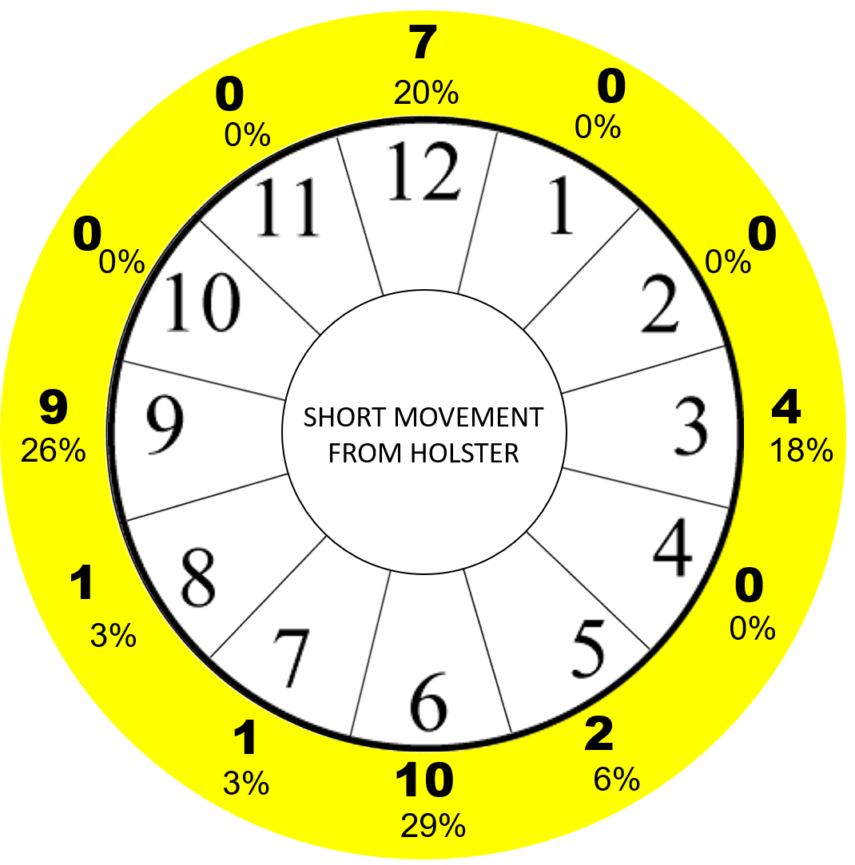

Short Movement from the Holster was conducted overwhelmingly in one of the 4 primary directions. Movement straight to the rear accounts for the largest percentage, while moving to the left was nearly as prevalent. Movements to the 9, 8, and 7 o’clock direction were primarily made while exiting the patrol vehicle to engage a threat. As in the SMR directional analysis, officers that engaged from the holster and moved forward did so exclusively when they were not under direct immediate, personal threat. These instances involved situations where the lethal threat was directed at another officer, victim or bystander.

Example Links:

https://www.youtube.com/watch?app=desktop&v=TjGqOfpUhwg&list=PL7csYbrPKf-wX976QRuXlZIa6ZAVjlFxz&index=2&t=265s
Short Movement from holster moving forward.

https://www.youtube.com/watch?app=desktop&v=LedIOsviysE
Short Movement from holster to the left.

https://www.instagram.com/p/CHHASEUp6-j/
Short Movement from holster to the left and back.

https://www.youtube.com/watch?app=desktop&v=kykw0Dch2iQ
Short Movement from holster to the rear and to the ground.

https://www.youtube.com/watch?app=desktop&v=2-N_LzuFbzY&list=PLFNuct3MvVGbOhxJpV2VaUpgFU917_K80&index=1
Short Movement from the holster to the rear.

5. MOVE THEN SHOOT

Overview
Statistically, Move then Shoot is the most probable pattern of movement by an officer in an LFE. These events account for 13% of all incidents (93/700) and 29% of all movement events (93/318). In an MTS movement pattern the officer is moving and then comes to a general stop to fire their rounds. This movement also saw the largest diversity of speed. Officers often used MTS in foot pursuits where they would go from a sprint to stopping as they fired. MTS was also used to close the distance with a suspect, reach other officers’ position, or laterally clear objects of cover and concealment. The majority of times officers employed MTS laterally, they were around vehicles, corners, or clearing an angle to address a suspect.

Move then Shoot can be either from the holster, ready, or aimed. Of the 93 MTS events recorded, 63 officers carried their firearms at the ready, 4 were aimed, and 26 were holstered. When observed through the lens of current training practices not enough attention is given to moving in a dynamic environment with a drawn handgun or ready rifle. While moving at the ready many officers removed their second hand from the handgun as soon as the distance was greater than 2-3 steps. Shorter MTS particularly while tracking a suspect and moving laterally saw the officers maintain a 2-handed grip. In all instances, the officers that maintained a 2-handed grip on the handgun or rifle moved at significantly slower speed than those that dismounted their second hand from the gun.

The most common call type in which MTS was employed was the Foot Pursuit, coming in at 30% of all MTS events. Weapons calls, which make up the statistically highest percentage overall, ranked low in MTS. Officers did not typically try to move closer to subjects known or believed to be armed. This is consistent with training practices that teach officers to increase distance from a threat to create greater reaction time and increase odds of a successful outcome. The exception again to this trend is when officers were chasing and attempting to apprehend a suspect.

Directionality

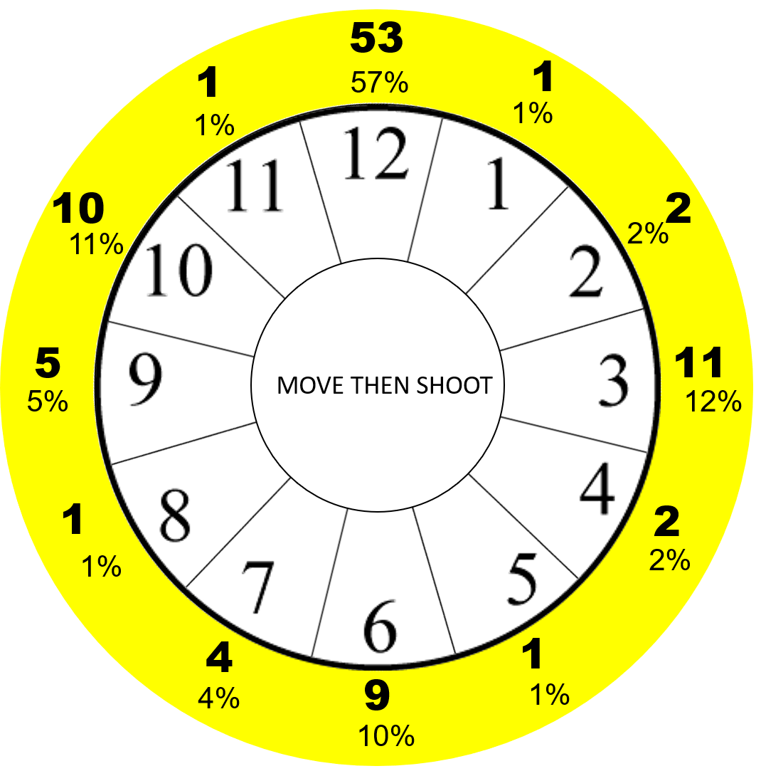
The directionality of MTS shows a strong emphasis on forward movement. Movement in the forward plane, accounts for more than 70% of all MTS events. Movement straight ahead or directly at a threat (12 o’clock) is 57%. Up to this point in the study this is the most signifigant directional trend observed. Much of this number can be attributed to foot pursuits which were the incident type in 28 of the 53 forward movement MTS cases. MTS also shows a much lower percentage of movements to the rear when compared to Short Movement Ready and Short Movement Holstered cases.

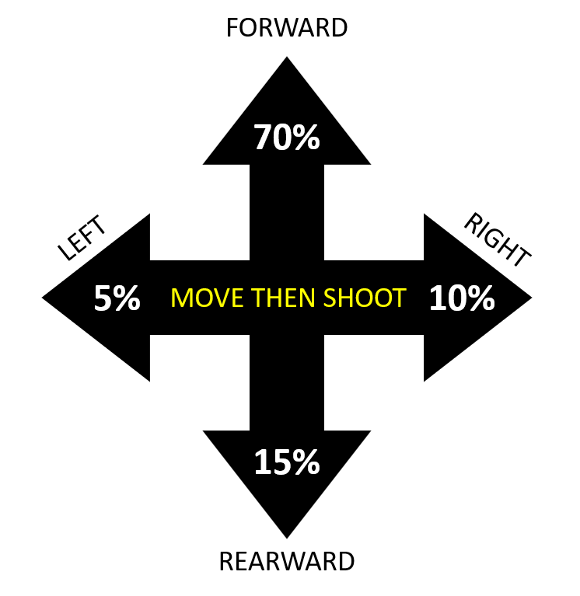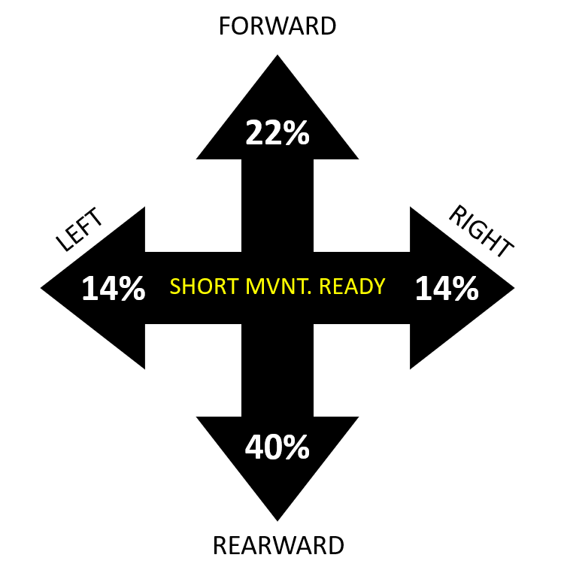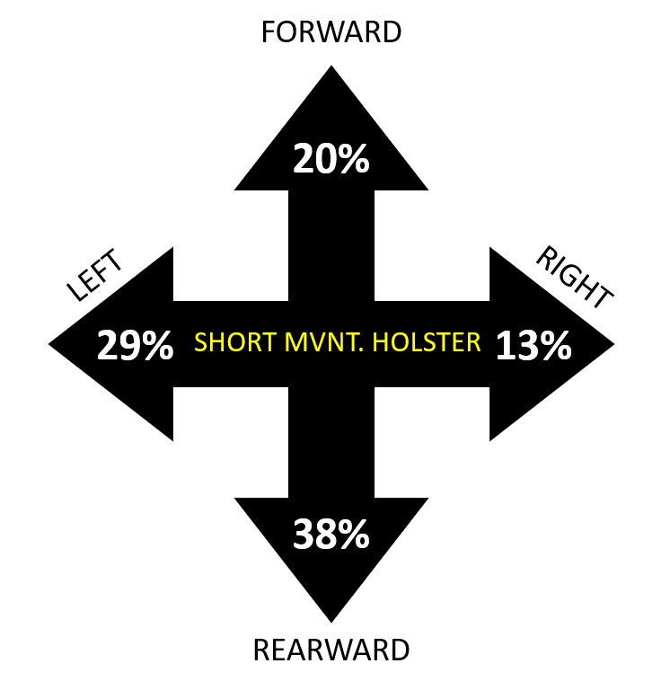

Example Links:

https://www.youtube.com/watch?v=96XE4n0kVFU&t=32s

https://www.youtube.com/watch?app=desktop&v=xz-hG26ZPy0

https://www.youtube.com/watch?app=desktop&v=p7yvSD_HB1M&list=PLII9g37Tnzh9qSJqe1c6niR--CynFgQcp&index=1

https://www.youtube.com/watch?app=desktop&v=DFr92aaAnKk

https://www.youtube.com/watch?app=desktop&v=9lJcr_yRJqc

6. SHOOTING ON THE MOVE

Overview
Shooting on the move is the most common form of movement training seen in Law Enforcement curriculum today. SOTM incidents made up 67 of the 700 incidents overall (10%), and accounted for 29% of all movement incidents.
Despite decades of specific training related to the how, the how not to, and the how fast, there was no deviation from normal walking, jogging, or running patterns used by the officer. The “how” question can be best answered by stating that officers moved typically using a gait that was relative to their overall posture. Most officers were in a lowered center of gravity at the time of their SOTM. I did not observe many instances in which officers conducted one of the specific SOTM movement techniques that have been taught such as Groucho or combat glide. Officers also did not seem to be concerned with specifics of where their feet were placed. Training range restrictions such as “never cross your feet,” did not appear to factor into officer’s movements at all. There were also no instances where officers appear to trip and fall over their own feet. Officers did go to the ground in several of the instances but those were exclusive to the rearward plane of movement and will be discussed further in the SOTM directionality section.

The speed at which officers conducted their SOTM varied considerably. Officers fired on the move in speeds ranging from a slow walk to sprinting. The speed at which an officer moved and then subsequently engaged a threat while moving, appears to be tied almost exclusively to the threat. The higher or closer a threat was to the officer, the faster the movement pattern. Instances where the officer was not the subject of the immediate threat produced the slowest movements. One anomaly observed with moving slowly was during situations where officer(s) were faced with an advancing subject with a non-projectile weapon. In the majority of these situations the officer’s movement speed matched the suspect’s as they attempted to keep a fixed distance between them. Officers would continue moving as they fired when the suspect would change speeds. Even a small change in the pace of movement by the suspect would often initiate the use of force by officers. The distance between officer and suspect in this situation varied from a few feet to nearly 30 feet. The phenomenon of matching pace did not seem to be affected by the distance.

Spot Example:
https://www.youtube.com/watch?app=desktop&v=9WQ-6oaYDZk&bpctr=1612194698

Directionality:
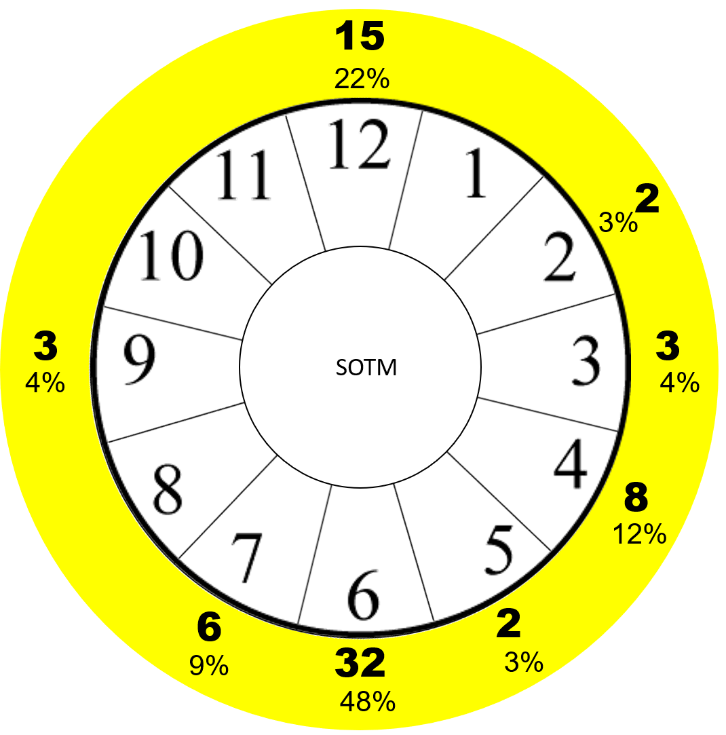

Officers that utilized SOTM in their Lethal Force Event were most likely to do so in a straight linear forward or rearward motion. Linear movements account for 70% of all SOTM with forward making up 22% and rearward 48%. Lateral continuous SOTM is rare, accounting for 8% of SOTM, 2% of all movement events and only 1% of the 700 studied events.

Rearward motion was nearly 50% of all SOTM events despite continued training to discourage rearward movement. Two distinct patterns were observed in rearward SOTM. The first was previously mentioned where officers back away from a suspect armed with a non-projectile weapon. In this incident type officer(s) were likely to match the pace of the suspect which was most commonly a walking pace. Officers continue to back away, giving commands, and in some incidents attempted to deploy less-lethal tools on the suspect. The directionality of this movement was almost always straight to the rear but occasionally rotated around a central object such as a vehicle. The most common response of officers in these calls was to stop their movement after firing the shots. Officers typically used a standard two-handed grip on their firearms unless they were also utilizing an auxiliary tool such as TASER, radio, or flashlight.

Another common rearward movement trend involved officers in a higher threat situation in which the movement was much faster. Officers being aggressively attacked, shot at or near a moving vehicle were more likely to fire while rapidly retreating. When faced with this type of threat the most common movement pattern is Protective Movement. In nearly 100% of protective movements if the officer was holstered, they did not attempt to fire until some distance had been gained. In instances where officers were aimed in or at the ready, officer’s reactions were split between SOTM and Protective Movement. When officers moved rapidly away from a threat and fired it was common for them to take a one-handed firing posture and fire rounds while simultaneously moving at their maximum capable speed.

There were multiple observed instances of Officers falling to the ground while moving to the rear. In each example observed, the officers were moving in a very dynamic manner while simultaneously lowering their posture to present a smaller target. The fall did not appear to be the product of a trip or obstruction but of the bodies inability to remain upright, moving backwards, with a lowered center of gravity. This particular pattern was also observed in Protective Movement when the officer makes no attempt to access a weapon on the ground but continues movement to escape the direct line of threat.

Forward SOTM was observed in nearly a quarter of all SOTM events. In the majority of all forward movements officers were not the subject of an immediate, personal threat. In some cases, there are multiple officers and the suspect is directing the threat at another officer. In other examples, officers fired while moving forward on a fleeing suspect. Occasionally officers fired on the move while in the middle of a foot pursuit however in almost all cases the officers stopped moving while firing or immediately after firing.

Example Links:

https://www.youtube.com/watch?app=desktop&v=fdei6FEmRN8

https://www.youtube.com/watch?v=CHBeRPxZ6KE&bpctr=1612199203

https://www.youtube.com/watch?app=desktop&v=XUsJp4GXBqs&list=PL7csYbrPKf-wX976QRuXlZIa6ZAVjlFxz&index=5&bpctr=1612199314

https://www.instagram.com/p/CJL0BWZnmvs/

https://www.youtube.com/watch?app=desktop&v=xT1fLCeZq7o&list=PLS9l6iTOHtppW7lnVincEcKjDFocW4grk&index=67

7. PROTECTIVE MOVEMENT

Overview
The Protective Movement pattern is the only option in which the officer does not immediately take steps to return fire against a suspect. In PM, the sole purpose of the officer is to gain distance or escape from the direct line of harm. Officers may access their weapon and then return fire from a static position or from one of the other 6 movement patterns. This lack of attempting to access force tools is what separates a protective movement from a standard Move Then Shoot which is often the secondary movement pattern observed. Protective Movement is the primary pattern observed when officers were ambushed unexpectedly. Correspondingly, officers were holstered in 100% of Protective Movement incidents (officers were armed with Patrol Rifles in 3 incidents). Also unique to PM is that 100% of the time Officers moved without any attempt at immediately returning fire, when under direct, immediate threat. All other movement types had instances where officers were under immediate threat and situations where they were not under immediate threat. The speed of Protective Movement was almost always at or near the maximum capable speed of the officer.

Directionality:

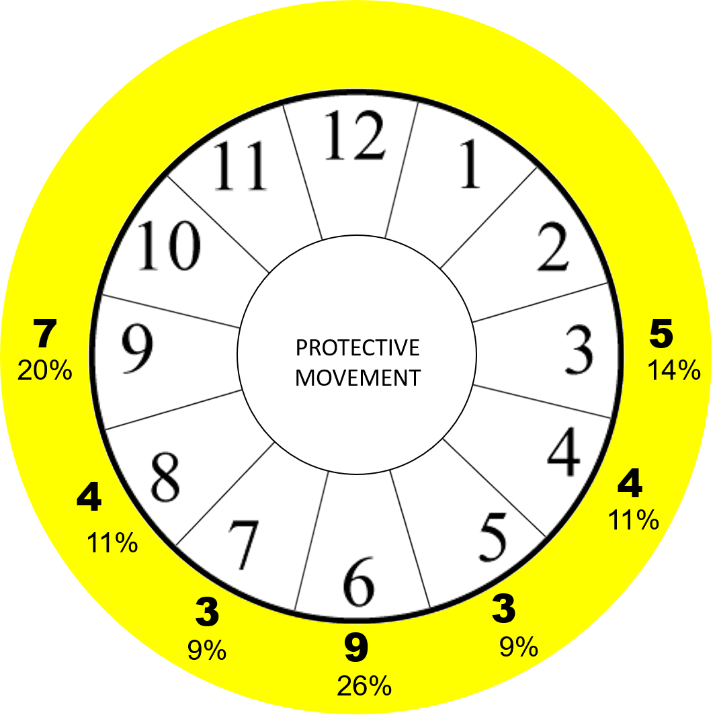

The directionality of Protective Movement is unique when compared to other types as it is the only pattern with zero instances of movement in the forward plane. This is understandable as this type of movement is initiated primarily by the threatening action of the suspect.

Movement straight to the rear represented the statistical majority in a single direction at 26%. Movement in the lateral plane combined to account for 34%. Lateral movement in instances observed were often tied to officers moving towards an object of cover/concealment. The alternate to this was officers moving to position an object of cover/concealment between themselves and the threat.

Example Links:

https://www.youtube.com/watch?app=desktop&v=X3j8-RF75P4&list=PLII9g37Tnzh9qSJqe1c6niR--CynFgQcp&index=5

https://www.youtube.com/watch?app=desktop&v=qeoX5mWlgK8&list=PLsNaX2vJHJ6yECoJGX7Jl58-cEsaim2kr&index=11

https://www.youtube.com/watch?app=desktop&v=zTht2sx-FrM

https://www.youtube.com/watch?app=desktop&v=hXrM66M14yo&t=43s

https://www.liveleak.com/view?t=aRit6_1608670798

SECTION 5 – SECONDARY MOVEMENT ANALYSIS

The purpose of the Secondary Movement Analysis is to evaluate how often officers use multiple movement patterns. The use of multiple types of movement is not statistically common, occurring in only 65 out of 700 incidents. Lethal Force Events are often sudden, rapid encounters and by the time an officer is prepared to change movement types, the force application portion of the event is over. Secondary movement patterns were identified only as those where officers continued to fire after transitioning from one movement style to another. Events were only listed as secondary movement if there was a clear distinction between the two movements.

The most common secondary movement pattern was non-movement. This matches with the overall findings that officers are likely to seek a stable position from which to deliver force. The second most likely movement was Move then Shoot. There were zero instances of turning movement and the remaining movement types all made up for a small percentage each.

Example Links:

https://www.youtube.com/watch?app=desktop&v=qot9TY4DiVg&list=PLsNaX2vJHJ6yECoJGX7Jl58-cEsaim2kr&index=24

https://www.youtube.com/watch?app=desktop&v=AJZ09g-QcCA&list=PL3aP220TI0pRzGjS0epvJKl4CV3wiEKJZ&index=48

https://www.liveleak.com/view?t=atgMH_1608585571

https://www.youtube.com/watch?app=desktop&v=o6rBowAlKtI

https://www.youtube.com/watch?app=desktop&v=7FPxRbGY2fM&list=PLS9l6iTOHtppW7lnVincEcKjDFocW4grk&index=60

SECTION 6 – RECOMMENDATIONS FOR TRAINING PRACTICES

From the first thought of studying the movements of Officers in Lethal Force Events, the purpose has always been to improve training practices. The following recommendations and observations are designed to expand and evolve current TTPs to be compliant with behavioral and statistical trends. Many traditional training practices have some value, but in the climate of limited training time, efficiencies in delivering information must be explored. The following recommendations are in no particular order of importance.

- Significantly increase the number of drills in which Officers start from a ready position. 80% of all incidents studied had the Officer begin the LFE with a drawn gun and speed of draw was not a factor. Speed to 1st hit is ALWAYS a factor in an LFE so working to increase efficiency from all positions is imperative. I recommend a 50/50 breakdown in holstered/ready starting positions. While there is merit to the idea of gaining the additional draw repetition, the timing of each is different. Officers will often find themselves having a drawn gun in various situations from relatively low/unknown threat to very imminent threats such as an armed, uncooperative suspect. Treat the ready position as seriously as that of the holstered handgun. Beginning drills from the ready should be incorporated into all phases of training, especially movement-based drills.

- Incorporate verbal commands into all drills. Verbal commands are often discussed but rarely practiced. Focus on having officers begin with simple, loud, forceful commands. Allow variation in the commands to drop from forceful to controlled tones. One off-topic observation from the video analysis portion was that continued, repeated, forceful commands rarely produced the desired result.

- Tying into recommendation #2, eradicate the verbal command of “show me your hands.” The command encourages a suspect to move during a stressful event. There were multiple instances of officers firing on unarmed suspects for moving their hands while being given the command to show their hands. Replace this practice with the command of “Don’t Move.”

- Reduce and modify turning movement drills, also commonly referred to as pivot drills. Changes in the orientation of the hips is a foundational block in any athletic endeavor including shooting and defensive tactics. However, in the current training format the time would be much better suited working on more applicable movement patterns. Eliminate all holstered turns where an officer simply turns, draws and fires. Also limit turning drills from ready when no other movement is present. Turning movements should be trained in two ways:

- As part of a compound movement with other types of movement.
i.e. Move then shoot that starts with a 90-degree turn.

- Rapid, aggressive turning movements to simulate tracking a moving suspect.

- Increase the emphasis on Short Movement from the Ready. SMR should be trained in all directions and drills should include open space as well as moving towards cover/concealment or extending past objects.

- When conducting Short Movement from Holster, add emphasis on starting from alternate positions such as seated. Many of the SMH events were officers drawing while exiting their cruisers. Add this movement and timing pattern into the training cycle.

- Stop demonizing movement to the rear. While it is not ideal to move in a manner we are not biologically designed to move efficiently, the reality is we often move away from danger. Refusing to train in the rearward plane of motion when we so frequently see it applied in real life is not behaviorally complaint. Incorporate drills moving to the rear and discuss advantages, disadvantages, and likely behavioral patterns. Simply telling officers to never back up will not prevent them from doing so in a real event. Place an emphasis on rearward movement in likely scenarios that would produce this behavior. Despite decades of training and reliance on the concepts of “muscle memory” to stop officers from moving to the rear, Officers moved to the rear in the statistic majority of all movement types. Of the true movement patterns (excluding NM and TM), only Move then Shoot did not show officers moving to the rear as the statistical majority.

- Focus on linear front and back movement when training Shooting on the Move. Eliminate the wasteful debates over lateral movement such as over crossing feet, tank turret, sidestep, etc. Focus on hits at a realistic pace to the given scenario. Rearward SOTM should be at a fast pace. Forward SOTM should be more controlled with a higher degree of accuracy required.

- Embrace alternate SOTM concepts beyond traditional methods. Train officers to rapidly create distance while simultaneously engaging a threat one handed. This type of drill is done at close distance and with signifigant urgency.

- Increase drills and pre-drills that require Officers to move with a drawn/ready weapon at various speeds. Conduct drills from a walking, jogging and sprinting paces. Set courses of fire that require officers to clear simple obstacles while drawn and work safely around other officers. This type of training must be taken in a crawl-walk-run methodology and should always be practiced dry first, prior to live-fire training. Officers often moved a considerable amount in the moments leading up to an LFE and then moved little once that LFE commenced.

- Movement is a considerable area of overlap with general Defensive Tactics / Arrest Control. This is the perfect opportunity to combine and co-teach with agency DT instructors. Focus on efficiency of motion, spatial awareness and control. When you explore the concepts and share notes, you will find this is the biggest crossover skill set between two often separate training groups.

- Match the overall training regime to the data. Understanding that all skills must be taught and maintained, strive to set the overall training breakdown to match observed trends. Roughly 50% of all LFE’s occurred with a static officer, match that on the range. Further incorporate the additional movement types in their appropriate breakdowns. Avoid over emphasis on necessary skills that are rarely seen. Officers must know these skills but should not apply a disproportionate amount of training to them. To illustrate this look at the number of times ancillary skills were applied in the 700 observed incidents.

- 20 Emergency Reloads 2%
- 2 Tactical Reloads .02%
- 1 Speed Reload .01%
- 6 Malfunction Clearances (ALL LV 1) .08%
- 1 Rifle to Handgun Transition .01%
*did not fire after transition

Combined, these ancillary skills only represented 2.12% of all incidents. Now examine how much of your training regime is dedicated to these topics. They are valid skills that must be known, understood and maintained. Ideally, once proficiency is obtained, skills are maintained at a level equal to their occurrences in actual events.

- Base all training methodologies decisions and practices on live-event data, behavioral compliance, and proven adult educational techniques. Do NOTHING in your training TTPs with the justification that it has been done this way in the past. Critically evaluate all information, drills, practices, COFs, and scenarios.

- Be diligent in updating, evolving, and growing your program. Observe trends and adjust accordingly even when that overwrites a previously held belief or training system.

SECTION 7 – CONCLUSION

The most important aspect of this study is its analysis and conclusions derived from the actual events officers found themselves encountering. For years I have sensed a disconnect in the way we train, teach, and understand the Officers’ movements. I have developed training programs and courses designed to address these shortcomings. This process was not fully understood until this deep dive into the videos with the focus primarily on how Officers move within an LFE.

Understanding these movements and how they interact with naturally occurring behavior patterns overtop the framework of current training methodologies allows us to better prepare officers in the future. Our role as instructors, mentors, and teachers is to guide our fellow Officers’ preparations in the most productive way possible, while exposing them to likely stimulus they will face in an actual fight.

Finally, as I watched hours upon hours of officers engaged in Lethal Force Events I am struck with a continued awe at the courage, dedication and sacrifice our Officers show each day. Let us never feel as though we have given enough to these brave Men and Women. Let us strive to be better prepared, better trained, and better evolved to prepare those who face this continuous threat.

R/S

Phillip Groff
Vigr Training LLC.
PO Box 32
Newmanstown PA 17073
Phone: 717.507.4853
Email: info@vigrtraining.com
Web: www.vigrtraining.com

SECTION 8 – VIDEO LINKS

https://www.youtube.com/playlist?list=PL7csYbrPKf-wX976QRuXlZIa6ZAVjlFxz
https://www.youtube.com/watch?v=qot9TY4DiVg&list=PLsNaX2vJHJ6yECoJGX7Jl58-cEsaim2kr&index=24
https://www.youtube.com/watch?v=AJZ09g-QcCA&list=PL3aP220TI0pRzGjS0epvJKl4CV3wiEKJZ&index=48
https://www.youtube.com/watch?v=MhoP161gpWM
https://www.youtube.com/watch?v=1QKGi50a2AQ
https://www.youtube.com/watch?v=4gb3DhrzHm8&list=PLS9l6iTOHtppW7lnVincEcKjDFocW4grk&index=71
https://www.youtube.com/watch?v=L0MwPpoWQRw&list=PL3aP220TI0pRSdTGR9g8d0jFfsUFVSA7Q&index=20
https://www.youtube.com/watch?v=zlH7kfdDGcs&bpctr=1609880020
https://www.youtube.com/watch?v=3cd9LA0Omkg
https://www.youtube.com/watch?v=s7xVnBHBMGA&t=104s
https://www.youtube.com/watch?v=TKAsgxhsk14
https://www.youtube.com/watch?v=j78QDwQJVv8
https://www.youtube.com/watch?v=p47ONDlR9aY
https://www.youtube.com/watch?v=DUmxMPijWYs
https://www.youtube.com/watch?v=kBpkuD6J0Vw&list=PLW5iqZEagvjMvmXRnBaYqozLYwmzUO2B9&index=48
https://www.youtube.com/watch?v=KbL8Da0EoGA&list=PLS9l6iTOHtppW7lnVincEcKjDFocW4grk&index=31
https://www.youtube.com/watch?v=uT4xIqavh5Q&list=PLPgkMKfX-f5GzI57j9fUMksqqoU_Qmtzh&index=9
https://www.youtube.com/watch?v=ZDgn53uI0qk&list=PLPgkMKfX-f5GzI57j9fUMksqqoU_Qmtzh&index=124
https://www.youtube.com/watch?v=_E6zokJUFi8&list=PLS9l6iTOHtppW7lnVincEcKjDFocW4grk&index=114
https://www.youtube.com/watch?v=HbmndIjg9tU&list=PL3aP220TI0pSynmM0ZFmYDdPJo-s-m1HC&index=63
https://www.youtube.com/watch?v=YS8yg9Yvlnc
https://www.youtube.com/watch?v=_GiEY4Okxwk&t=265s
https://www.youtube.com/watch?v=JGnhlXSGdYM
https://www.youtube.com/watch?v=6YVKSLMlNY8&list=PL3aP220TI0pSynmM0ZFmYDdPJo-s-m1HC&index=44
https://www.youtube.com/watch?v=fUq0FHN_hng&list=PLW5iqZEagvjMvmXRnBaYqozLYwmzUO2B9&index=14
https://www.youtube.com/watch?v=TKjkA45fH5Y
https://www.youtube.com/watch?v=0oSHNZQkhOE
https://www.youtube.com/watch?v=8IaKznkDD3g
https://www.youtube.com/watch?v=DFr92aaAnKk
https://www.liveleak.com/view?t=k1RqM_1609897761
https://www.liveleak.com/view?t=aRit6_1608670798
https://www.youtube.com/watch?v=aSPf1ZwJRMA&list=PLPgkMKfX-f5GzI57j9fUMksqqoU_Qmtzh&index=160
https://www.instagram.com/p/CJtZ82uHHNn/
https://www.instagram.com/p/CHAsQglJtKh/
https://www.youtube.com/watch?v=X3j8-RF75P4&list=PLII9g37Tnzh9qSJqe1c6niR--CynFgQcp&index=5
https://www.youtube.com/watch?v=dNw70KPuPpc&list=PLsNaX2vJHJ6yECoJGX7Jl58-cEsaim2kr&index=6
https://www.youtube.com/watch?v=KI07i0izYc0&list=PLsNaX2vJHJ6yECoJGX7Jl58-cEsaim2kr&index=20
https://www.youtube.com/watch?v=xFcUZ3osIf4&list=PL3aP220TI0pRzGjS0epvJKl4CV3wiEKJZ&index=111&bpctr=1610995294
https://www.youtube.com/watch?v=xKZbfog-wlw&list=PL3aP220TI0pRzGjS0epvJKl4CV3wiEKJZ&index=128&bpctr=1610996399
https://www.youtube.com/watch?v=24gECuCSYec&t=110s&bpctr=1611020675
https://www.youtube.com/watch?v=24gECuCSYec&t=110s&bpctr=1611020675
https://www.youtube.com/watch?v=24gECuCSYec&t=110s&bpctr=1611020675
https://www.youtube.com/watch?v=r-dcZaPTKdQ
https://www.youtube.com/watch?v=vOvmbD_deKY
https://www.youtube.com/watch?v=amRvzu-ERaQ
https://www.youtube.com/watch?v=oU0ncR7399Q&list=PLkoSMeOY5v46xNbhVljin9fF1g_S6qlrI&index=26
https://www.youtube.com/watch?v=TjGqOfpUhwg&list=PL7csYbrPKf-wX976QRuXlZIa6ZAVjlFxz&index=2&t=265s
https://www.youtube.com/watch?v=0C4RS89X7Bw
https://www.youtube.com/watch?v=eP8waTkVQoE&list=PLW5iqZEagvjMvmXRnBaYqozLYwmzUO2B9&index=71
https://www.youtube.com/watch?v=Y7SztlfOGXY&list=PLsNaX2vJHJ6yECoJGX7Jl58-cEsaim2kr&index=18
https://www.liveleak.com/view?t=atgMH_1608585571
https://www.youtube.com/watch?v=_I54MEdD2_A&bpctr=1609889823
https://www.youtube.com/watch?v=2QQul-WKDx4
https://www.youtube.com/watch?v=EEu3SZ-XrPU&t=1s
https://www.youtube.com/watch?v=o6rBowAlKtI
https://www.youtube.com/watch?v=VuuB6h3C37o
https://www.youtube.com/watch?v=VRz1orUorgs&t=34s
https://www.youtube.com/watch?v=u8QBVss04dc&t=6s
https://www.youtube.com/watch?v=mdsnjn3PwcI
https://www.youtube.com/watch?v=AGVsNsFimZM
https://www.youtube.com/watch?v=ucXCnY4a09o
https://www.youtube.com/watch?v=amRvzu-ERaQ
https://www.youtube.com/watch?v=C5_XkThyaWk&bpctr=1609885947
https://www.youtube.com/watch?v=M_bF7i2_ok4
https://www.youtube.com/watch?v=ji6INhImanM
https://www.youtube.com/watch?v=dne8aTg8WVY
https://www.youtube.com/watch?v=eZGUlFIKhfM
https://www.liveleak.com/view?t=Cq4zQ_1604123244
https://www.youtube.com/watch?v=ZhkPPr4Gpa4&list=PLS9l6iTOHtppW7lnVincEcKjDFocW4grk&index=35
https://www.youtube.com/watch?v=k7CTCp9rFSQ&list=PLPgkMKfX-f5GzI57j9fUMksqqoU_Qmtzh&index=26
https://www.youtube.com/watch?v=7FPxRbGY2fM&list=PLS9l6iTOHtppW7lnVincEcKjDFocW4grk&index=60
https://www.instagram.com/p/CIkzVTBJkXk/
https://www.youtube.com/watch?v=6ziVTWgGWcM&list=PL3aP220TI0pSynmM0ZFmYDdPJo-s-m1HC&index=28
https://www.youtube.com/watch?v=TZPOxyQ_Z4E
https://www.youtube.com/watch?v=24gECuCSYec&t=110s&bpctr=1611020675
https://www.youtube.com/watch?v=lNmD0H1W_uM&list=PLS9l6iTOHtppW7lnVincEcKjDFocW4grk&index=57
https://www.youtube.com/watch?v=AqLhe1jHIB4&list=PLS9l6iTOHtppW7lnVincEcKjDFocW4grk&index=58
https://www.youtube.com/watch?v=LvbyJFIEW2U&list=PL7csYbrPKf-wX976QRuXlZIa6ZAVjlFxz&index=3
https://www.youtube.com/watch?v=-SA9iHt5RVs&list=PL7csYbrPKf-wX976QRuXlZIa6ZAVjlFxz&index=4&t=58s
https://www.youtube.com/watch?v=XUsJp4GXBqs&list=PL7csYbrPKf-wX976QRuXlZIa6ZAVjlFxz&index=5&bpctr=1607975956
https://www.youtube.com/watch?v=TYbBgCUgZmU&list=PL7csYbrPKf-wX976QRuXlZIa6ZAVjlFxz&index=6&bpctr=1607976155
https://www.youtube.com/watch?v=lBs4T8cEGPM&list=PL7csYbrPKf-wX976QRuXlZIa6ZAVjlFxz&index=7
https://www.youtube.com/watch?v=p2GlvtBYIbw&list=PL7csYbrPKf-wX976QRuXlZIa6ZAVjlFxz&index=15&bpctr=1607976467
https://www.youtube.com/watch?v=4Veqe0-8k9U&list=PL7csYbrPKf-wX976QRuXlZIa6ZAVjlFxz&index=16&bpctr=1607976621
https://www.youtube.com/watch?v=Y72w8s-kXq4&bpctr=1609877069
https://www.youtube.com/watch?v=kyBhmKnb81o
https://www.youtube.com/watch?v=A-NkkEv47Ro
https://www.youtube.com/watch?v=UQjGBrURQJE&bpctr=1609879632
https://www.youtube.com/watch?v=zoEnWaD_D6Q&bpctr=1609879791
https://www.youtube.com/watch?v=b-G0UDvUUos
https://www.youtube.com/watch?v=4xyAaG2aZNU&bpctr=1609880325
https://www.youtube.com/watch?v=ZhXq6pCwSQk
https://www.youtube.com/watch?v=h7gOJmlSUms&bpctr=1609885509
https://www.youtube.com/watch?v=ntFanbnGwNk&bpctr=1609885768
https://www.youtube.com/watch?v=t1DcAVrwwU4&bpctr=1609886243
https://www.youtube.com/watch?v=bH77wNPIe0I
https://www.youtube.com/watch?v=QwTDxr9St-0&bpctr=1609886614
https://www.youtube.com/watch?v=RE9fVYJWcKA
https://www.youtube.com/watch?v=p8TbEclL81o
https://www.youtube.com/watch?v=YS8yg9Yvlnc
https://www.youtube.com/watch?v=2HKkK2kAzu0
https://www.youtube.com/watch?v=ShE1Vs2UTSQ&bpctr=1609890315
https://www.youtube.com/watch?v=9WQ-6oaYDZk&bpctr=1609890335
https://www.youtube.com/watch?v=8zGa9zRNC9w
https://www.youtube.com/watch?v=gR7orxjZgEQ
https://www.youtube.com/watch?v=l_dE_aMiD6E
https://www.youtube.com/watch?v=kAMOFvfmhhk
https://www.youtube.com/watch?v=4O2IReqaYqw&bpctr=1609891199
https://www.youtube.com/watch?v=fctVaK6o5uE
https://www.youtube.com/watch?v=wJGlVIW9Zqc
https://www.youtube.com/watch?v=rGYej3o5zW8
https://www.youtube.com/watch?v=ygbOLb0O7Pw&bpctr=1609891988
https://www.youtube.com/watch?v=ykc-hoY_F04&bpctr=1609892099
https://www.youtube.com/watch?v=cWvzwxSgPGM&bpctr=1609892607
https://www.youtube.com/watch?v=idYTp9uando
https://www.youtube.com/watch?v=nZ7_cCQTjsw
https://www.youtube.com/watch?v=pkprJwyEK8M
https://www.youtube.com/watch?v=-rwTNm2eLRE
https://www.youtube.com/watch?v=lu3GpXCCZzs
https://www.youtube.com/watch?v=cBYI-e-JmH4&bpctr=1609893599
https://www.youtube.com/watch?v=Dg34VnNXR-k
https://www.youtube.com/watch?v=-zo7mfZYmbM
https://www.youtube.com/watch?v=ZOqjJYQINhw
https://www.youtube.com/watch?v=55v4fBHjZ8Q
https://www.youtube.com/watch?v=rWpQPn_A798&bpctr=1609940329
https://www.youtube.com/watch?v=6Citg5Xqsl0
https://www.youtube.com/watch?v=47kjmF89o4M
https://www.youtube.com/watch?v=KVOjJf6gYuw
https://www.youtube.com/watch?v=a22lD1IVmaE
https://www.youtube.com/watch?v=ThmRQM1-XnU&bpctr=1609941075
https://www.youtube.com/watch?v=5mtI2Nlaaj4
https://www.youtube.com/watch?v=ks_DvfssE6c
https://www.youtube.com/watch?v=RU1tkawlR7A&bpctr=1609941636
https://www.youtube.com/watch?v=MQJw-FG06Dc
https://www.youtube.com/watch?v=Ncg1g5KdAV0
https://www.youtube.com/watch?v=AYGaNYAyKuw
https://www.youtube.com/watch?v=VTr5iTfi6h8
https://www.youtube.com/watch?v=l1jYP0VEbAU&bpctr=1609942551
https://www.youtube.com/watch?v=AJwHT3Cb9tQ
https://www.youtube.com/watch?v=a2r5zMQEhbI&t=59s
https://www.youtube.com/watch?v=KXPLyVK5oQ0
https://www.youtube.com/watch?v=X_vNHb9q5_I
https://www.youtube.com/watch?v=GLbKSysIc6Q&t=1s
https://www.youtube.com/watch?v=wS66JLhWwF8
https://www.youtube.com/watch?v=hRJYuJDXK_4
https://www.youtube.com/watch?v=XMI1YVGGr7g
https://www.youtube.com/watch?v=_7tHacBMHuY
https://www.youtube.com/watch?v=9H4VaoQ9_MQ
https://www.youtube.com/watch?v=7mc0-JYAOVk
https://www.youtube.com/watch?v=JWmZyALMK-w
https://www.youtube.com/watch?v=bcJJ-tPXMnQ
https://www.youtube.com/watch?v=IcftqD8oCFU
https://www.youtube.com/watch?v=tUmMMA9LtJs&bpctr=1609943993
https://www.youtube.com/watch?v=a1X5eJPNZYM
https://www.youtube.com/watch?v=0C4RS89X7Bw
https://www.youtube.com/watch?v=GBQnY57mWyc
https://www.youtube.com/watch?v=1hrst9RnSUA
https://www.youtube.com/watch?v=eC3d0Qc1eVE
https://www.youtube.com/watch?v=aIXnRdHiIzE
https://www.youtube.com/watch?v=i-FZ9Zqxu94&bpctr=1609945383
https://www.youtube.com/watch?v=MaKzHtYbho0
https://www.youtube.com/watch?v=886aGBrEwIU
https://www.youtube.com/watch?v=K7ZbPA8cG2Y
https://www.youtube.com/watch?v=0oSHNZQkhOE
https://www.youtube.com/watch?v=py66xIDStxQ
https://www.youtube.com/watch?v=EyETt6Mv3yw
https://www.youtube.com/watch?v=zT-7zhIxl6Y&t=27s
https://www.youtube.com/watch?v=yIGvA1XmcbM
https://www.youtube.com/watch?v=cwhfPDjfIxE
https://www.youtube.com/watch?v=5B7Tq879SP0
https://www.youtube.com/watch?v=m7H3XR3_ccc
https://www.youtube.com/watch?v=ynWBfhzMEV4
https://www.youtube.com/watch?v=PEhT5wqn9tY&t=51s
https://www.youtube.com/watch?v=fdei6FEmRN8
https://www.youtube.com/watch?v=8fX-31BHUFw&t=268s
https://www.youtube.com/watch?v=oqhaWnPHXoY&t=75s
https://www.youtube.com/watch?v=kCkWtgtHdCE
https://www.youtube.com/watch?v=zEkibPaqZAs
https://www.youtube.com/watch?v=w2aYQvI8D5Q
https://www.youtube.com/watch?v=IbBHvCw1RkA
https://www.youtube.com/watch?v=0fZCnVRWZic
https://www.youtube.com/watch?v=ffcKdZ3-1VQ
https://www.youtube.com/watch?v=sMjrZP_z888
https://www.youtube.com/watch?v=T_Es9K_1z_w
https://www.youtube.com/watch?v=ALmK1qvm77E
https://www.youtube.com/watch?v=NZjc4dHN6Dc
https://www.youtube.com/watch?v=ApeQJo0VuHs&bpctr=1609984287
https://www.youtube.com/watch?v=PgzamwVv-FM
https://www.youtube.com/watch?v=LCWO1TX_BeU
https://www.youtube.com/watch?v=4sppZTuAcaI
https://www.youtube.com/watch?v=vNDKB4_IKEw
https://www.youtube.com/watch?v=MIxlbtjrk60
https://www.youtube.com/watch?v=TwkpYq1bLmE
https://www.youtube.com/watch?v=JFTjVSDCQUw
https://www.youtube.com/watch?v=b8zvkg-Aneg
https://www.youtube.com/watch?v=4SjbBTQuDss
https://www.youtube.com/watch?v=RKE-CoPhpQo
https://www.youtube.com/watch?v=evK-mOBP4As
https://www.youtube.com/watch?v=8IaKznkDD3g
https://www.youtube.com/watch?v=q0WL6So0-EI
https://www.youtube.com/watch?v=ENnphXEW1Ng
https://www.youtube.com/watch?v=I0MeeloG8bM&t=66s
https://www.youtube.com/watch?v=TKAsgxhsk14
https://www.youtube.com/watch?v=wSIh2yvcVuc
https://www.youtube.com/watch?v=JHU0cmHviH0&t=10s
https://www.youtube.com/watch?v=2lqJ0TllapM
https://www.youtube.com/watch?v=XNp5OTtssok
https://www.youtube.com/watch?v=UokZZSwNy_8&bpctr=1610068647
https://www.youtube.com/watch?v=tZbtWN1skkQ
https://www.youtube.com/watch?v=lnUdmVWEC9A&t=21s
https://www.youtube.com/watch?v=bVr5z3RJ6VI
https://www.youtube.com/watch?v=Jhb5NfHcvMo
https://www.youtube.com/watch?v=RCF5j1Z0bhk
https://www.youtube.com/watch?v=48Xw0rMdcHI&bpctr=1610069727
https://www.youtube.com/watch?v=n5eywLoLCJs
https://www.youtube.com/watch?v=GPcrIyMFvDo
https://www.youtube.com/watch?v=31PFcm_TJ6E
https://www.youtube.com/watch?v=88KUKcxpTQg
https://www.youtube.com/watch?v=ujXYsAZD1V4
https://www.youtube.com/watch?v=3R40nzHb6mA
https://www.youtube.com/watch?v=A7ixHrBsobA
https://www.youtube.com/watch?v=uC3_6S88CwA
https://www.youtube.com/watch?v=xaJ_ckmtbxw&t=66s
https://www.youtube.com/watch?v=NK1nQcmMNRQ
https://www.youtube.com/watch?v=NK1nQcmMNRQ
https://www.youtube.com/watch?v=_VokKxNbop0
https://www.youtube.com/watch?v=7Of4XP3Pvb0
https://www.youtube.com/watch?v=ym8yJBj4Qu8
https://www.youtube.com/watch?v=ET1MVGrBMT0
https://www.youtube.com/watch?v=IzociekIWRA&t=1545s
https://www.youtube.com/watch?v=R7sDdrjm3m0
https://www.youtube.com/watch?v=mlBr7TnG1BA
https://www.youtube.com/watch?v=fYQac758acw
https://www.youtube.com/watch?v=kmmS6uVNDKU
https://www.youtube.com/watch?v=oTQr_lKg_wg
https://www.youtube.com/watch?v=qdLV1xqD_2I
https://www.youtube.com/watch?v=1DzYVBqsmfk&t=76s
https://www.youtube.com/watch?v=s-4PuLXyRrQ
https://www.youtube.com/watch?v=lXTZZ3ZCzTc
https://www.youtube.com/watch?v=YqdqZT_LuAg
https://www.youtube.com/watch?v=2W7cbegGOt8&t=24s
https://www.youtube.com/watch?v=JK4OaEuN-cw
https://www.youtube.com/watch?v=Hw5XeHRG864
https://www.youtube.com/watch?v=J5SU2TTcM9Q
https://www.youtube.com/watch?v=DFU-mgND8pg
https://www.youtube.com/watch?v=iREshxsmt8c&t=133s&bpctr=1610074183
https://www.youtube.com/watch?v=DCcCe0Nwcmc
https://www.youtube.com/watch?v=jp93L_WxyN8&t=23s
https://www.youtube.com/watch?v=_al0rp9f3Vo&t=184s
https://www.youtube.com/watch?v=p_hZRMG0C6Y
https://www.youtube.com/watch?v=MrVBY-mTOpk
https://www.youtube.com/watch?v=iaxjRR3zy4U
https://www.youtube.com/watch?v=iaxjRR3zy4U
https://www.youtube.com/watch?v=I64b82OEjNE
https://www.youtube.com/watch?v=eDOKbZDg69Q
https://www.youtube.com/watch?v=2tZJeJfB8WA
https://www.youtube.com/watch?v=iRj_R0z6XR4
https://www.youtube.com/watch?v=GAXlxrRF_6g
https://www.youtube.com/watch?v=BvChaajJQrw
https://www.youtube.com/watch?v=vU7c5Ay3TKE
https://www.youtube.com/watch?v=mXdX4SB3paA
https://www.youtube.com/watch?v=QNyXZCeAriM
https://www.youtube.com/watch?v=dZgmN0l-hog
https://www.youtube.com/watch?v=_ikYXNpnzRs
https://www.youtube.com/watch?v=WCxQyg7d3_8
https://www.youtube.com/watch?v=6B22t-OmErA&t=218s
https://www.youtube.com/watch?v=vOMNaJXparE&bpctr=1610125791
https://www.youtube.com/watch?v=LedIOsviysE
https://www.youtube.com/watch?v=Di3OhY08Ahg
https://www.youtube.com/watch?v=f4J0Du-9gbk&t=55s
https://www.youtube.com/watch?v=gHemnuqeSRs
https://www.youtube.com/watch?v=EnnEiWDrnxo
https://www.youtube.com/watch?v=LV0RGNs3P_s
https://www.youtube.com/watch?v=GX40dElEIos&t=72s
https://www.youtube.com/watch?v=gdklmDTxf3A
https://www.youtube.com/watch?v=Hor44p22cmk
https://www.youtube.com/watch?v=AKaTMrVRYn8
https://www.youtube.com/watch?v=Mn_PzB8gI84
https://www.youtube.com/watch?v=7KP-Un0PbII
https://www.youtube.com/watch?v=I-Fld9K0H0M
https://www.youtube.com/watch?v=85JTqwgvOeQ
https://www.youtube.com/watch?v=HMlzW6iVrRA
https://www.youtube.com/watch?v=HMlzW6iVrRA
https://www.youtube.com/watch?v=6cz0hOMODvk
https://www.youtube.com/watch?v=aoOMyUgU_o4
https://www.youtube.com/watch?v=wmQTfs3DyAM
https://www.youtube.com/watch?v=RuGx2aKO1U0&t=73s
https://www.youtube.com/watch?v=ZvCR2oiKF_4
https://www.youtube.com/watch?v=fBJyYGo7uTU
https://www.youtube.com/watch?v=PMKcWz5nNoM
https://www.youtube.com/watch?v=6kkcapNSyWY
https://www.youtube.com/watch?v=peiJDs5hoJA
https://www.youtube.com/watch?v=ji6INhImanM
https://www.youtube.com/watch?v=3hQmnrPhxFU
https://www.youtube.com/watch?v=EGzR-7i5Pa8
https://www.youtube.com/watch?v=lOkazoQ7y8s
https://www.youtube.com/watch?v=ocXC0_Xohyo
https://www.youtube.com/watch?v=L161LW6-R_A
https://www.youtube.com/watch?v=kykw0Dch2iQ
https://www.youtube.com/watch?v=lr0NFyD0Nzw
https://www.youtube.com/watch?v=Gz88Q8pTMGQ
https://www.youtube.com/watch?v=-V3dKsmJQo4
https://www.youtube.com/watch?v=csTFaXt2Ud0
https://www.youtube.com/watch?v=T-0xBEMkTi4
https://www.youtube.com/watch?v=ETU4GVTvC4g
https://www.youtube.com/watch?v=rx2Fxm0Cf4A&t=4s
https://www.youtube.com/watch?v=2c8fC0dZteQ
https://www.youtube.com/watch?v=_hEld3oUVC0
https://www.youtube.com/watch?v=tUQlCVXth7I
https://www.youtube.com/watch?v=exlgx0BPayI
https://www.youtube.com/watch?v=ujf9iaPsAMw
https://www.youtube.com/watch?v=MtK04qf_t60
https://www.youtube.com/watch?v=nL21QNmy-a4
https://www.youtube.com/watch?v=ttHzh0TuskM
https://www.youtube.com/watch?v=9lJcr_yRJqc
https://www.youtube.com/watch?v=LfVYK1mnyqQ
https://www.youtube.com/watch?v=fexMzfomUok
https://www.youtube.com/watch?v=3zHeP7usFXI
https://www.youtube.com/watch?v=d1S4Qg6ccBw
https://www.youtube.com/watch?v=FNJW-QXIup4&bpctr=1610144102
https://www.youtube.com/watch?v=d-3r8lhdwnY
https://www.youtube.com/watch?v=yHK41COLq6Y
https://www.youtube.com/watch?v=VM_hGHChFMI
https://www.youtube.com/watch?v=GCZH8Bv-8BA
https://www.youtube.com/watch?v=CGbQz-HmPko
https://www.youtube.com/watch?v=p47ONDlR9aY
https://www.youtube.com/watch?v=cyJPwEpTMrY
https://www.youtube.com/watch?v=HoDGcTWqDaI
https://www.youtube.com/watch?v=UXceyZLGyyU
https://www.youtube.com/watch?v=O_RZbk7eIu0
https://www.youtube.com/watch?v=EvFFPzw3N1U
https://www.youtube.com/watch?v=EvFFPzw3N1U
https://www.youtube.com/watch?v=zTht2sx-FrM
https://www.youtube.com/watch?v=a53Dk1l8wZU
https://www.youtube.com/watch?v=13U6-inlWEI
https://www.youtube.com/watch?v=ypEN1ay5i78
https://www.youtube.com/watch?v=agHAxvCWr1A
https://www.youtube.com/watch?v=SSxTBfs-YDc
https://www.youtube.com/watch?v=cdBifHq5PYc
https://www.youtube.com/watch?v=m3hFJ0DYvY4
https://www.youtube.com/watch?v=vSo1Nwr5KLA
https://www.youtube.com/watch?v=M1v8pRukTeg
https://www.youtube.com/watch?v=PPSUKuSOQ-o
https://www.youtube.com/watch?v=uXgE97NHErg
https://www.youtube.com/watch?v=ihJLOmFFPn0
https://www.youtube.com/watch?v=JyJZpSsvv5k
https://www.youtube.com/watch?v=G5pgZ0yq1-E&t=25s
https://www.youtube.com/watch?v=U1lIZwO4zKM
https://www.youtube.com/watch?v=yew26h1i4Q8
https://www.youtube.com/watch?v=EmJSCeKIPrE
https://www.youtube.com/watch?v=Oo9ysdAQom4
https://www.youtube.com/watch?v=nU_A6zLaIxs&t=1s
https://www.youtube.com/watch?v=fby9yCLWzSE
https://www.youtube.com/watch?v=fby9yCLWzSE
https://www.youtube.com/watch?v=caHM_g5eZU8
https://www.youtube.com/watch?v=IGqz5_AtInQ
https://www.youtube.com/watch?v=cQEh0FH84i0
https://www.youtube.com/watch?v=4buDqSE3Vx4
https://www.youtube.com/watch?v=J50R9G_5Enw
https://www.youtube.com/watch?v=c6Nd1KWHVnM
https://www.youtube.com/watch?v=5URCA9GXdp4
https://www.youtube.com/watch?v=AgDoDKqgr0M
https://www.youtube.com/watch?v=oHMYM9VzNYw&list=PL7csYbrPKf-zz09U1uVvt0ew00Myy4gIP&index=1
https://www.youtube.com/watch?v=hXrM66M14yo&t=43s
https://www.youtube.com/watch?v=awe0YaQXVJA
https://www.youtube.com/watch?v=ZwuduMZq5qg
https://www.youtube.com/watch?v=PUxx4t-zBy0
https://www.youtube.com/watch?v=PtBOtC3cJOs
https://www.youtube.com/watch?v=-QtFI7RlZ3Y
https://www.youtube.com/watch?v=sxy90X9VBsg&bpctr=1610299770
https://www.youtube.com/watch?v=wGeiiJWejNc
https://www.youtube.com/watch?v=47swe9Q6cJ8&t=3s
https://www.youtube.com/watch?v=J-PK8t8vtSM&bpctr=1610300066
https://www.youtube.com/watch?v=96XE4n0kVFU
https://www.youtube.com/watch?v=BYk1JkUnl-k&list=PLW5iqZEagvjMvmXRnBaYqozLYwmzUO2B9&index=3
https://www.youtube.com/watch?v=BXBrkeyYDFo&list=PLW5iqZEagvjMvmXRnBaYqozLYwmzUO2B9&index=6
https://www.youtube.com/watch?v=dDORLOsm2ss&list=PLW5iqZEagvjMvmXRnBaYqozLYwmzUO2B9&index=7
https://www.youtube.com/watch?v=J-PvN4V9NIQ&list=PLW5iqZEagvjMvmXRnBaYqozLYwmzUO2B9&index=8
https://www.youtube.com/watch?v=Qq0d9InBYWU&list=PLW5iqZEagvjMvmXRnBaYqozLYwmzUO2B9&index=12
https://www.youtube.com/watch?v=7O-oNSmp_BY&list=PLW5iqZEagvjMvmXRnBaYqozLYwmzUO2B9&index=19
https://www.youtube.com/watch?v=dGdN4Tfs3p0&list=PLW5iqZEagvjMvmXRnBaYqozLYwmzUO2B9&index=20
https://www.youtube.com/watch?v=dSjUuhD2F0M&list=PLW5iqZEagvjMvmXRnBaYqozLYwmzUO2B9&index=21
https://www.youtube.com/watch?v=dSjUuhD2F0M&list=PLW5iqZEagvjMvmXRnBaYqozLYwmzUO2B9&index=21
https://www.youtube.com/watch?v=pqRACiHxcPQ&list=PLW5iqZEagvjMvmXRnBaYqozLYwmzUO2B9&index=28
https://www.youtube.com/watch?v=UW3rWDzlqUE&list=PLW5iqZEagvjMvmXRnBaYqozLYwmzUO2B9&index=38
https://www.youtube.com/watch?v=BBbNGoPh5kk&list=PLW5iqZEagvjMvmXRnBaYqozLYwmzUO2B9&index=39
https://www.youtube.com/watch?v=GWR-TG1SaMo&list=PLW5iqZEagvjMvmXRnBaYqozLYwmzUO2B9&index=41
https://www.youtube.com/watch?v=2yVVn48mYf4&list=PLW5iqZEagvjMvmXRnBaYqozLYwmzUO2B9&index=44
https://www.youtube.com/watch?v=yBjIGwGSb4g&list=PLW5iqZEagvjMvmXRnBaYqozLYwmzUO2B9&index=45
https://www.youtube.com/watch?v=RhbTLlM2TdU&list=PLW5iqZEagvjMvmXRnBaYqozLYwmzUO2B9&index=46
https://www.youtube.com/watch?v=Ca-HFSiNiQU&list=PLW5iqZEagvjMvmXRnBaYqozLYwmzUO2B9&index=50
https://www.youtube.com/watch?v=U8Xpyz1FbQg&list=PLW5iqZEagvjMvmXRnBaYqozLYwmzUO2B9&index=78
https://www.youtube.com/watch?v=uXPrOZjLfEk&list=PLW5iqZEagvjMvmXRnBaYqozLYwmzUO2B9&index=72
https://www.liveleak.com/view?t=k1RqM_1609897761
https://www.liveleak.com/view?t=kQGym_1609508101
https://www.liveleak.com/view?t=kaEE3_1602810454
https://www.liveleak.com/view?t=kaEE3_1602810454
https://www.liveleak.com/view?t=kqe9b_1603510191
https://www.youtube.com/watch?v=liP19Mw69os&bpctr=1610330205
https://www.youtube.com/watch?v=VnF-JmE5NUA&list=PLFNuct3MvVGbOhxJpV2VaUpgFU917_K80&index=17
https://www.youtube.com/watch?v=1ZHPYYuj02c&list=PLFNuct3MvVGbOhxJpV2VaUpgFU917_K80&index=15
https://www.youtube.com/watch?v=bb3_tzeTnFQ&list=PLFNuct3MvVGbOhxJpV2VaUpgFU917_K80&index=14
https://www.youtube.com/watch?v=2-N_LzuFbzY&list=PLFNuct3MvVGbOhxJpV2VaUpgFU917_K80&index=1
https://www.youtube.com/watch?v=py9SFTmsc6s&list=PLFNuct3MvVGbOhxJpV2VaUpgFU917_K80&index=3
https://www.youtube.com/watch?v=BlntJX-JmAc&list=PLFNuct3MvVGbOhxJpV2VaUpgFU917_K80&index=7
https://www.youtube.com/watch?v=7Plq-RG0q8U&list=PLFNuct3MvVGbOhxJpV2VaUpgFU917_K80&index=8
https://www.youtube.com/watch?v=9jHZwaOtK4A&list=PLFNuct3MvVGbOhxJpV2VaUpgFU917_K80&index=9
https://www.youtube.com/watch?v=C9jeWVPBbrQ&list=PLFNuct3MvVGbOhxJpV2VaUpgFU917_K80&index=10
https://www.youtube.com/watch?v=-4MDxBTprFY&list=PLDYaXhKcg7F01b8wfZOgUShu2cXGUm-it&index=17
https://www.instagram.com/p/CKB8g94nk04/
https://www.instagram.com/p/CKB7nyrHK-N/
https://www.instagram.com/p/CKB7IuNH29Y/
https://www.instagram.com/p/CJ_t34_HWPG/
https://www.instagram.com/p/CJ_sZhMnLnh/
https://www.youtube.com/watch?v=XcC3qfcng8c&list=PLS9l6iTOHtppW7lnVincEcKjDFocW4grk&index=4
https://www.youtube.com/watch?v=Kgy71pEyd5c&list=PLS9l6iTOHtppW7lnVincEcKjDFocW4grk&index=6
https://www.youtube.com/watch?v=6W0pzk0w96g
https://www.youtube.com/watch?v=7vXUSHhIB28&list=PLS9l6iTOHtppW7lnVincEcKjDFocW4grk&index=9
https://www.youtube.com/watch?v=7BOwuYlqNxM&list=PLS9l6iTOHtppW7lnVincEcKjDFocW4grk&index=10
https://www.youtube.com/watch?v=YtZpQa2YOGU&list=PLS9l6iTOHtppW7lnVincEcKjDFocW4grk&index=12
https://www.youtube.com/watch?v=oRk3uvag3i8&list=PLS9l6iTOHtppW7lnVincEcKjDFocW4grk&index=13
https://www.youtube.com/watch?v=Qu9tNcjoO3k&list=PLS9l6iTOHtppW7lnVincEcKjDFocW4grk&index=14
https://www.youtube.com/watch?v=V-2w75b7_ys&list=PLS9l6iTOHtppW7lnVincEcKjDFocW4grk&index=15
https://www.youtube.com/watch?v=0mRycUgaSuQ&list=PLS9l6iTOHtppW7lnVincEcKjDFocW4grk&index=18
https://www.youtube.com/watch?v=ekDjBcv5d2o&list=PLS9l6iTOHtppW7lnVincEcKjDFocW4grk&index=21
https://www.youtube.com/watch?v=MKXOiEYSqgA&list=PLS9l6iTOHtppW7lnVincEcKjDFocW4grk&index=22
https://www.youtube.com/watch?v=ke-Mw1F2odM&list=PLS9l6iTOHtppW7lnVincEcKjDFocW4grk&index=23
https://www.youtube.com/watch?v=l4JWag8knRo&list=PLS9l6iTOHtppW7lnVincEcKjDFocW4grk&index=25
https://www.youtube.com/watch?v=Cgq6NlTMCvk&list=PLS9l6iTOHtppW7lnVincEcKjDFocW4grk&index=26
https://www.youtube.com/watch?v=ixkdn4TN_mo&list=PLS9l6iTOHtppW7lnVincEcKjDFocW4grk&index=29
https://www.youtube.com/watch?v=gENiDI6f__A&list=PLS9l6iTOHtppW7lnVincEcKjDFocW4grk&index=30
https://www.youtube.com/watch?v=zbsaWnJuhBM&list=PLS9l6iTOHtppW7lnVincEcKjDFocW4grk&index=37
https://www.youtube.com/watch?v=MSue7KvMKyo&list=PLS9l6iTOHtppW7lnVincEcKjDFocW4grk&index=38
https://www.youtube.com/watch?v=tuRqtJvynTs&list=PLfLWSO3y8hfODiB6ZfFRlxRh11xsWDfc_&index=2
https://www.youtube.com/watch?v=bpA8OfzUZDQ&list=PLfLWSO3y8hfODiB6ZfFRlxRh11xsWDfc_&index=6
https://www.youtube.com/watch?v=__1eTmwobxs&list=PLfLWSO3y8hfODiB6ZfFRlxRh11xsWDfc_&index=5&bpctr=1610646333
https://www.youtube.com/watch?v=drTBMCA4Y6E&list=PLB489D2561E1B2A1C&index=10
https://www.youtube.com/watch?v=acL_q5k2czM&list=PLPgkMKfX-f5GzI57j9fUMksqqoU_Qmtzh&index=1
https://www.youtube.com/watch?v=y63mXpynoAs&list=PLPgkMKfX-f5GzI57j9fUMksqqoU_Qmtzh&index=4
https://www.youtube.com/watch?v=uT4xIqavh5Q&list=PLPgkMKfX-f5GzI57j9fUMksqqoU_Qmtzh&index=9
https://www.youtube.com/watch?v=Hs4Q9kaJjIg&list=PLPgkMKfX-f5GzI57j9fUMksqqoU_Qmtzh&index=14
https://www.youtube.com/watch?v=LX5Wd6DER_A&list=PLPgkMKfX-f5GzI57j9fUMksqqoU_Qmtzh&index=16
https://www.youtube.com/watch?v=3hpGLxi68zw&list=PLPgkMKfX-f5GzI57j9fUMksqqoU_Qmtzh&index=20
https://www.youtube.com/watch?v=SXW5PxAp-Tw&list=PLPgkMKfX-f5GzI57j9fUMksqqoU_Qmtzh&index=28
https://www.youtube.com/watch?v=u7lkqqCXGeg&list=PLPgkMKfX-f5GzI57j9fUMksqqoU_Qmtzh&index=30
https://www.youtube.com/watch?v=n0e8B-VY5ls&list=PLPgkMKfX-f5GzI57j9fUMksqqoU_Qmtzh&index=32
https://www.youtube.com/watch?v=9AudwyVyDbQ&list=PLPgkMKfX-f5GzI57j9fUMksqqoU_Qmtzh&index=37
https://www.youtube.com/watch?v=uLKroMAlpyE&list=PLPgkMKfX-f5GzI57j9fUMksqqoU_Qmtzh&index=44
https://www.youtube.com/watch?v=In120OTTkkY&list=PLPgkMKfX-f5GzI57j9fUMksqqoU_Qmtzh&index=46
https://www.youtube.com/watch?v=mHsMGJ3Vhpc&list=PLPgkMKfX-f5GzI57j9fUMksqqoU_Qmtzh&index=48
https://www.youtube.com/watch?v=8I_zbGwD3MM&list=PLPgkMKfX-f5GzI57j9fUMksqqoU_Qmtzh&index=52
https://www.youtube.com/watch?v=2CEgu6cyk-Y&list=PLPgkMKfX-f5GzI57j9fUMksqqoU_Qmtzh&index=56
https://www.youtube.com/watch?v=GHW81QzLFbA&list=PLPgkMKfX-f5GzI57j9fUMksqqoU_Qmtzh&index=63
https://www.youtube.com/watch?v=WJPydBkCQLg&list=PLPgkMKfX-f5GzI57j9fUMksqqoU_Qmtzh&index=68
https://www.youtube.com/watch?v=LCEHgUVNIDU&list=PLPgkMKfX-f5GzI57j9fUMksqqoU_Qmtzh&index=72
https://www.youtube.com/watch?v=sSU92HdPIYA&list=PLPgkMKfX-f5GzI57j9fUMksqqoU_Qmtzh&index=74
https://www.youtube.com/watch?v=SOeei_e9o7Y&list=PLPgkMKfX-f5GzI57j9fUMksqqoU_Qmtzh&index=77
https://www.youtube.com/watch?v=GsF4tHzb94Q&list=PLPgkMKfX-f5GzI57j9fUMksqqoU_Qmtzh&index=80
https://www.youtube.com/watch?v=7ylN12X5PvM&list=PLPgkMKfX-f5GzI57j9fUMksqqoU_Qmtzh&index=83
https://www.youtube.com/watch?v=o-jq_ZoG-pM&list=PLPgkMKfX-f5GzI57j9fUMksqqoU_Qmtzh&index=93
https://www.youtube.com/watch?v=149PvISJozo&list=PLPgkMKfX-f5GzI57j9fUMksqqoU_Qmtzh&index=95
https://www.youtube.com/watch?v=ZNSksiTaRcw&list=PLPgkMKfX-f5GzI57j9fUMksqqoU_Qmtzh&index=97
https://www.youtube.com/watch?v=W8XOublYMAk&list=PLPgkMKfX-f5GzI57j9fUMksqqoU_Qmtzh&index=99
https://www.youtube.com/watch?v=5jH_GoCphzM&list=PLPgkMKfX-f5GzI57j9fUMksqqoU_Qmtzh&index=101
https://www.youtube.com/watch?v=Fp2JNeC0HfM&list=PLPgkMKfX-f5GzI57j9fUMksqqoU_Qmtzh&index=103
https://www.youtube.com/watch?v=2JJ3veRsEXs&list=PLPgkMKfX-f5GzI57j9fUMksqqoU_Qmtzh&index=104
https://www.youtube.com/watch?v=42oMsa7dhQE&list=PLPgkMKfX-f5GzI57j9fUMksqqoU_Qmtzh&index=108
https://www.youtube.com/watch?v=lLwPr_WS73c&list=PLPgkMKfX-f5GzI57j9fUMksqqoU_Qmtzh&index=112
https://www.youtube.com/watch?v=BxXC-dRIY5A&list=PLPgkMKfX-f5GzI57j9fUMksqqoU_Qmtzh&index=117
https://www.youtube.com/watch?v=YArhw6T514U&list=PLPgkMKfX-f5GzI57j9fUMksqqoU_Qmtzh&index=122
https://www.youtube.com/watch?v=ZDgn53uI0qk&list=PLPgkMKfX-f5GzI57j9fUMksqqoU_Qmtzh&index=124
https://www.youtube.com/watch?v=q3kdOzW3j4E&list=PLPgkMKfX-f5GzI57j9fUMksqqoU_Qmtzh&index=126
https://www.youtube.com/watch?v=qlQY4oII_jg&list=PLPgkMKfX-f5GzI57j9fUMksqqoU_Qmtzh&index=130
https://www.youtube.com/watch?v=TojpFVD5WIo&list=PLPgkMKfX-f5GzI57j9fUMksqqoU_Qmtzh&index=144
https://www.youtube.com/watch?v=d6dwYW9Yp7c&list=PLPgkMKfX-f5GzI57j9fUMksqqoU_Qmtzh&index=148
https://www.youtube.com/watch?v=6wdOhuJgQEA&list=PLPgkMKfX-f5GzI57j9fUMksqqoU_Qmtzh&index=152
https://www.youtube.com/watch?v=LQHuzJDlddA&list=PLPgkMKfX-f5GzI57j9fUMksqqoU_Qmtzh&index=154
https://www.youtube.com/watch?v=mcT8OYDzklo&list=PLPgkMKfX-f5GzI57j9fUMksqqoU_Qmtzh&index=158
https://www.youtube.com/watch?v=JqnQjXkjpY8&list=PLPgkMKfX-f5GzI57j9fUMksqqoU_Qmtzh&index=166
https://www.youtube.com/watch?v=W8kex8Zs_h8&list=PLPgkMKfX-f5GzI57j9fUMksqqoU_Qmtzh&index=187
https://www.youtube.com/watch?v=-1vOxHMP6Bw&list=PLPgkMKfX-f5GzI57j9fUMksqqoU_Qmtzh&index=192
https://www.youtube.com/watch?v=kL7jeAI_LeI&list=PLPgkMKfX-f5GzI57j9fUMksqqoU_Qmtzh&index=204
https://www.instagram.com/p/CJ1PNRrnbFN/
https://www.instagram.com/p/CJrVWYnnuhc/
https://www.instagram.com/p/CJe_It0HBAD/
https://www.instagram.com/p/CJeAFw6Hw5w/
https://www.instagram.com/p/CJPOJugn7Ly/
https://www.instagram.com/p/CJL0i_MHGIU/
https://www.instagram.com/p/CJL0BWZnmvs/
https://www.instagram.com/p/CJLzFw3n6OR/
https://www.instagram.com/p/CJD76oTnlSB/
https://www.youtube.com/watch?v=9okMzh8SxXU&list=PLS9l6iTOHtppW7lnVincEcKjDFocW4grk&index=52
https://www.youtube.com/watch?v=eB_qXHhwDYg&list=PLS9l6iTOHtppW7lnVincEcKjDFocW4grk&index=54
https://www.youtube.com/watch?v=eB_qXHhwDYg&list=PLS9l6iTOHtppW7lnVincEcKjDFocW4grk&index=54
https://www.youtube.com/watch?v=3ZId27XOvqA&list=PLS9l6iTOHtppW7lnVincEcKjDFocW4grk&index=59
https://www.youtube.com/watch?v=GfwR3KTKDwE&list=PLS9l6iTOHtppW7lnVincEcKjDFocW4grk&index=61
https://www.youtube.com/watch?v=cgWt7Li-UlQ&list=PLS9l6iTOHtppW7lnVincEcKjDFocW4grk&index=64
https://www.youtube.com/watch?v=7LBpQ9A9y6s&list=PLS9l6iTOHtppW7lnVincEcKjDFocW4grk&index=66
https://www.youtube.com/watch?v=xT1fLCeZq7o&list=PLS9l6iTOHtppW7lnVincEcKjDFocW4grk&index=67
https://www.youtube.com/watch?v=NfE3s12yW5g&list=PLS9l6iTOHtppW7lnVincEcKjDFocW4grk&index=69
https://www.youtube.com/watch?v=PGD8vKJCDTM&list=PLS9l6iTOHtppW7lnVincEcKjDFocW4grk&index=73
https://www.youtube.com/watch?v=-32OpLHnDmY&list=PLS9l6iTOHtppW7lnVincEcKjDFocW4grk&index=74
https://www.youtube.com/watch?v=6n29vxMjWWk&list=PLS9l6iTOHtppW7lnVincEcKjDFocW4grk&index=75
https://www.youtube.com/watch?v=OAn_VVOuGxE&list=PLS9l6iTOHtppW7lnVincEcKjDFocW4grk&index=78
https://www.youtube.com/watch?v=i8dXv9MlTGU&list=PLS9l6iTOHtppW7lnVincEcKjDFocW4grk&index=84
https://www.youtube.com/watch?v=i8dXv9MlTGU&list=PLS9l6iTOHtppW7lnVincEcKjDFocW4grk&index=84
https://www.youtube.com/watch?v=PiVosTcPQgs&list=PLS9l6iTOHtppW7lnVincEcKjDFocW4grk&index=86
https://www.youtube.com/watch?v=cFLwgxFrvsg&list=PLS9l6iTOHtppW7lnVincEcKjDFocW4grk&index=87
https://www.youtube.com/watch?v=ulv0gQdJm3w&list=PLS9l6iTOHtppW7lnVincEcKjDFocW4grk&index=88
https://www.youtube.com/watch?v=uVT0_0Zc-c4&list=PLS9l6iTOHtppW7lnVincEcKjDFocW4grk&index=115
https://www.youtube.com/watch?v=eOEC_DK8PSo&list=PLS9l6iTOHtppW7lnVincEcKjDFocW4grk&index=128
https://www.youtube.com/watch?v=pR1g9q0KPtE&list=PLS9l6iTOHtppW7lnVincEcKjDFocW4grk&index=130
https://www.youtube.com/watch?v=9DnkRj7Xi3k&list=PLS9l6iTOHtppW7lnVincEcKjDFocW4grk&index=131
https://www.youtube.com/watch?v=rjyNT_BJI6I&list=PL2D338AE5FE7E5108&index=7
https://www.youtube.com/watch?v=sKeUE6UHIEM
https://www.instagram.com/p/CItXDBbnIIR/
https://www.instagram.com/p/CIozKmdJWDe/
https://www.instagram.com/p/CIoyeXAJaiz/
https://www.instagram.com/p/CIE6GN4JXzA/
https://www.instagram.com/p/CH_j3gcJGAw/
https://www.instagram.com/p/CH-sRWOJzeI/
https://www.instagram.com/p/CHsZrBNpjD7/
https://www.instagram.com/p/CHlxpKKJwgj/
https://www.instagram.com/p/CHI7SAOJffQ/
https://www.instagram.com/p/CHHElc4pjYK/
https://www.instagram.com/p/CHHASEUp6-j/
https://www.instagram.com/p/CG7pho4p1Tt/
https://www.youtube.com/watch?v=MR8bJURU288&list=PL0kBIN5Zbb7JFX5FMM_K0J75KPXRUm8DJ&index=1
https://www.liveleak.com/view?t=CtXY6_1605114022
https://www.youtube.com/watch?v=42whkhsl548&list=PLsNaX2vJHJ6yECoJGX7Jl58-cEsaim2kr&index=32
https://www.youtube.com/watch?v=NXw5QSUzdk4&list=PLII9g37Tnzh9e9wwPtD3eYwz_TCNFXpZX&index=3
https://www.youtube.com/watch?v=p7yvSD_HB1M&list=PLII9g37Tnzh9qSJqe1c6niR--CynFgQcp&index=1
https://www.youtube.com/watch?v=pdvYVwUkOD4&list=PLII9g37Tnzh9qSJqe1c6niR--CynFgQcp&index=2
https://www.youtube.com/watch?v=Ai9KJh_RWDs&list=PLII9g37Tnzh9qSJqe1c6niR--CynFgQcp&index=6
https://www.youtube.com/watch?v=6zhjcden5Ag&list=PLII9g37Tnzh9qSJqe1c6niR--CynFgQcp&index=16
https://www.youtube.com/watch?v=olohRLSkuXc&list=PLII9g37Tnzh9qSJqe1c6niR--CynFgQcp&index=26
https://www.youtube.com/watch?v=iK8spIF_k3c&list=PLsNaX2vJHJ6yECoJGX7Jl58-cEsaim2kr&index=5
https://www.youtube.com/watch?v=9aM4RqavxcQ&list=PLsNaX2vJHJ6yECoJGX7Jl58-cEsaim2kr&index=9
https://www.youtube.com/watch?v=qeoX5mWlgK8&list=PLsNaX2vJHJ6yECoJGX7Jl58-cEsaim2kr&index=11
https://www.youtube.com/watch?v=16xUelkla7Q&list=PLsNaX2vJHJ6yECoJGX7Jl58-cEsaim2kr&index=19
https://www.youtube.com/watch?v=lEHpkUsMW20&list=PLsNaX2vJHJ6yECoJGX7Jl58-cEsaim2kr&index=22
https://www.youtube.com/watch?v=JVeUZ2DENCs&list=PLsNaX2vJHJ6yECoJGX7Jl58-cEsaim2kr&index=23
https://www.youtube.com/watch?v=gtoyBjPFhfs&list=PLsNaX2vJHJ6yECoJGX7Jl58-cEsaim2kr&index=38
https://www.youtube.com/watch?v=4v8Vw3yEBz4&list=PL3aP220TI0pRSdTGR9g8d0jFfsUFVSA7Q&index=6
https://www.youtube.com/watch?v=Zb1Et30pnMs&list=PL3aP220TI0pRSdTGR9g8d0jFfsUFVSA7Q&index=4
https://www.youtube.com/watch?v=bs8AOf7yQbI&list=PL3aP220TI0pRSdTGR9g8d0jFfsUFVSA7Q&index=12
https://www.police1.com/police-products/body-cameras/articles/video-footage-of-fatal-houston-ois-refutes-claims-suspect-was-unarmed-07TD3n8tRmLukdYd/
https://www.click2houston.com/news/local/2020/12/21/la-marque-police-release-bodycam-video-from-fatal-shooting-of-joshua-feast/
https://www.youtube.com/watch?v=bmd8GoXwilw&list=PL3aP220TI0pSynmM0ZFmYDdPJo-s-m1HC&index=1
https://www.youtube.com/watch?v=g7xumCuKXlw&list=PL3aP220TI0pSynmM0ZFmYDdPJo-s-m1HC&index=2
https://www.youtube.com/watch?v=eVko45B5M1A&list=PL3aP220TI0pSynmM0ZFmYDdPJo-s-m1HC&index=3&bpctr=1610748811
https://www.youtube.com/watch?v=bcQhjxZKFAo&list=PL3aP220TI0pSynmM0ZFmYDdPJo-s-m1HC&index=4&bpctr=1610749056
https://www.youtube.com/watch?v=7SdUznSqasU&list=PL3aP220TI0pSynmM0ZFmYDdPJo-s-m1HC&index=9
https://www.youtube.com/watch?v=pL84CCuNhJo&list=PL3aP220TI0pSynmM0ZFmYDdPJo-s-m1HC&index=11
https://www.youtube.com/watch?v=OdI9juNeRjw&list=PL3aP220TI0pSynmM0ZFmYDdPJo-s-m1HC&index=15
https://www.youtube.com/watch?v=-X-nYL5aA9Q&list=PL3aP220TI0pSynmM0ZFmYDdPJo-s-m1HC&index=20
https://www.youtube.com/watch?v=R1ApnuSefpc&list=PL3aP220TI0pSynmM0ZFmYDdPJo-s-m1HC&index=23
https://www.youtube.com/watch?v=bZRuAwRZqCc&list=PL3aP220TI0pSynmM0ZFmYDdPJo-s-m1HC&index=25
https://www.youtube.com/watch?v=aFkGwtNkIpE&list=PL3aP220TI0pSynmM0ZFmYDdPJo-s-m1HC&index=26
https://www.youtube.com/watch?v=eCuH0f9AX6Q&list=PL3aP220TI0pSynmM0ZFmYDdPJo-s-m1HC&index=41
https://www.youtube.com/watch?v=CDBsaBINOF8&list=PL3aP220TI0pSynmM0ZFmYDdPJo-s-m1HC&index=42
https://www.youtube.com/watch?v=IkL6xyaFrWo&list=PL3aP220TI0pSynmM0ZFmYDdPJo-s-m1HC&index=43
https://www.youtube.com/watch?v=078KAno2ufk&list=PL3aP220TI0pSynmM0ZFmYDdPJo-s-m1HC&index=49
https://www.youtube.com/watch?v=54t6feKTP0M&list=PL3aP220TI0pSynmM0ZFmYDdPJo-s-m1HC&index=54
https://www.youtube.com/watch?v=54t6feKTP0M&list=PL3aP220TI0pSynmM0ZFmYDdPJo-s-m1HC&index=54
https://www.youtube.com/watch?v=pGtrSpVKmyE&list=PL3aP220TI0pSynmM0ZFmYDdPJo-s-m1HC&index=58
https://www.youtube.com/watch?v=HbmndIjg9tU&list=PL3aP220TI0pSynmM0ZFmYDdPJo-s-m1HC&index=63
https://www.youtube.com/watch?v=HbmndIjg9tU&list=PL3aP220TI0pSynmM0ZFmYDdPJo-s-m1HC&index=63
https://www.youtube.com/watch?v=iYov40nIvuo&list=PL3aP220TI0pSynmM0ZFmYDdPJo-s-m1HC&index=64
https://www.youtube.com/watch?v=nEDdiJVVdy4&list=PL3aP220TI0pRzGjS0epvJKl4CV3wiEKJZ&index=28
https://www.youtube.com/watch?v=oCsID8oqV1w&list=PL3aP220TI0pRzGjS0epvJKl4CV3wiEKJZ&index=32
https://www.youtube.com/watch?v=GwAYMQ9GOUA&list=PL3aP220TI0pRzGjS0epvJKl4CV3wiEKJZ&index=41&bpctr=1610827056
https://www.youtube.com/watch?v=VCAgSZHOsj8&list=PL3aP220TI0pRzGjS0epvJKl4CV3wiEKJZ&index=42&bpctr=1610827328
https://www.youtube.com/watch?v=FbysVaaIrhk&list=PL3aP220TI0pRzGjS0epvJKl4CV3wiEKJZ&index=44
https://www.youtube.com/watch?v=g0n09YaHsrs&list=PL3aP220TI0pRzGjS0epvJKl4CV3wiEKJZ&index=45&bpctr=1610827983
https://www.youtube.com/watch?v=mSBKR5wpphU&list=PL3aP220TI0pRzGjS0epvJKl4CV3wiEKJZ&index=50&bpctr=1610991493
https://www.youtube.com/watch?v=HaNJRkwWjpk&list=PL3aP220TI0pRzGjS0epvJKl4CV3wiEKJZ&index=57
https://www.youtube.com/watch?v=Dg4Ns79YX9A&list=PL3aP220TI0pRzGjS0epvJKl4CV3wiEKJZ&index=60
https://www.youtube.com/watch?v=KjXApxIAKG8&list=PL3aP220TI0pRzGjS0epvJKl4CV3wiEKJZ&index=62
https://www.youtube.com/watch?v=iVezELC5ulo&list=PL3aP220TI0pRzGjS0epvJKl4CV3wiEKJZ&index=84
https://www.youtube.com/watch?v=gv38DNjiCeE&list=PL3aP220TI0pRzGjS0epvJKl4CV3wiEKJZ&index=97
https://www.youtube.com/watch?v=ys53wkSjbRE&list=PL3aP220TI0pRzGjS0epvJKl4CV3wiEKJZ&index=98
https://www.youtube.com/watch?v=J3KzhR54E0g&list=PL3aP220TI0pRzGjS0epvJKl4CV3wiEKJZ&index=105
https://www.youtube.com/watch?v=WqYR30_lKPI&list=PL3aP220TI0pRzGjS0epvJKl4CV3wiEKJZ&index=114
https://www.youtube.com/watch?v=WqYR30_lKPI&list=PL3aP220TI0pRzGjS0epvJKl4CV3wiEKJZ&index=114
https://www.youtube.com/watch?v=xKZbfog-wlw&list=PL3aP220TI0pRzGjS0epvJKl4CV3wiEKJZ&index=128&bpctr=1610996399
https://www.youtube.com/watch?v=aojfNPPD81Y&list=PL3aP220TI0pRzGjS0epvJKl4CV3wiEKJZ&index=135
https://www.youtube.com/watch?v=TWJlRJ00RZM&list=PL3aP220TI0pRzGjS0epvJKl4CV3wiEKJZ&index=139
https://www.youtube.com/watch?v=g0n09YaHsrs&list=PL3aP220TI0pQVQuGzOhJmxFiQC9LpgfDg&index=5&bpctr=1610997579
https://www.youtube.com/watch?v=g0n09YaHsrs&list=PL3aP220TI0pQVQuGzOhJmxFiQC9LpgfDg&index=7&bpctr=1610997810
https://www.youtube.com/watch?v=Mhq0yI1tNlQ
https://www.youtube.com/watch?v=iqGs7ZvsuUw
https://www.youtube.com/watch?v=r-dcZaPTKdQ
https://www.youtube.com/watch?v=103f4l3U_yw
https://www.youtube.com/watch?v=Tx6y6ovHo5o
https://www.youtube.com/watch?v=ljt7KbFv35g
https://www.youtube.com/watch?v=a-CqChPRlWk
https://www.youtube.com/watch?v=tMoScPiwExk
https://www.youtube.com/watch?v=ZPk9tNUBgRQ
https://www.youtube.com/watch?v=ZN3JjkItnlo
https://www.youtube.com/watch?v=6sIpKBi9nHo
https://www.youtube.com/watch?v=6sIpKBi9nHo
https://www.youtube.com/watch?v=Jaslr_xQmkQ
https://www.youtube.com/watch?v=YbPvEtXHclA
https://www.youtube.com/watch?v=akip_pwHdgg
https://www.youtube.com/watch?v=ucXCnY4a09o
https://www.youtube.com/watch?v=ZBnC-mYwprE
https://www.youtube.com/watch?v=amRvzu-ERaQ
https://www.youtube.com/watch?v=Qg4ikf4EOjM&t=6s&bpctr=1611073692
https://www.youtube.com/watch?v=yks7nlQsCIg
https://www.youtube.com/watch?v=bg6Ka01eVlI
https://www.youtube.com/watch?v=CEchiakgVaI
https://www.youtube.com/watch?v=adbdvSwMrYw
https://www.youtube.com/watch?v=4DB0RrEUIWc&bpctr=1611076304
https://www.youtube.com/watch?v=fBr6c12xrE8&list=PLkoSMeOY5v46xNbhVljin9fF1g_S6qlrI&index=1
https://www.youtube.com/watch?v=T2A1PwEyGZs&list=PLkoSMeOY5v46xNbhVljin9fF1g_S6qlrI&index=27
https://www.youtube.com/watch?v=7ELBOxvJIU4&list=PLkoSMeOY5v46xNbhVljin9fF1g_S6qlrI&index=49
https://www.youtube.com/watch?v=y1qITD-IBXA&list=PLkoSMeOY5v46xNbhVljin9fF1g_S6qlrI&index=50
https://www.youtube.com/watch?v=zG1zeqpAbR4
https://www.youtube.com/watch?v=xz-hG26ZPy0
https://www.youtube.com/watch?v=z_PXle-vzbw
https://www.youtube.com/watch?v=yswOMw_N57m
https://www.youtube.com/watch?v=nXqX4vi2lf4
* In some videos, the actions of multiple officers were recorded if their movements were clearly observed. This is the reason there are less than 700 linked videos.

